2023

Big Data Architecture & Governance



**Assignment Name:**

# Traffic Violations Montgomery

**Student Names:**

**Akshita Pathania**

**Aishwarya Mishra**

**Disha Sengar**

Contents

2. Assignment 2

2.1. Case 2

2.2. Assignment Goals 2

2.2.1. Visualization Deliverables 3

2.2.2. OTHER DELIVERABLES 3

3. Documentation 4

3.1. Vision Diagram 4

3.2. Data Wrangling and Cleansing 5

3.3. Database Installation 6

3.4. Data Mapping and Integration 7

3.5. Data Validation and Data Visualization 8

3.6. System Integration and User Acceptance Testing 9

3.7. Challenges Encountered 10

3.8. End User Instructions 11

# Assignment

## Case



Montgomery Traffic Violations Dataset

* The dataset contains traffic violation information from all electronic traffic violations issued in the County from 2012-2023
* The dataset originally had 1.85 M records and 43 Columns
* The project involved collecting the data from the official website:   
  <https://data.montgomerycountymd.gov/Public-Safety/Traffic-Violations/4mse-ku6q>  
    
  Then we did Data Profiling ,Data Analysis ,Data Modelling ,Loading the data in Neo4j Database and then connected the database with Tableau to create Data Visualizations to derive insights from data.
* Following are the different Tools we used in our Project:
* Jupyter Notebook –

For Data Gathering, Data Profiling ,Data Wrangling & Data Analysis

* Neo4j Database –

For creating the database and loading the Traffic Violations data

* Visio.io – For Creating Data model diagram
* Tableau – For creating Data Visualizations
* Velero – For Project Management

## Assignment Goals

To work with datasets, Perform/Create:

* We created project in Velero:
  + Project

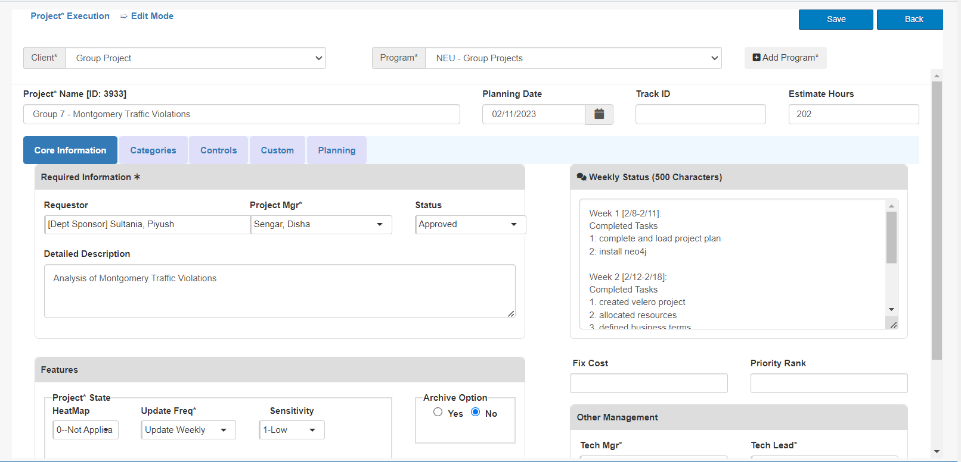

* + Project Plan

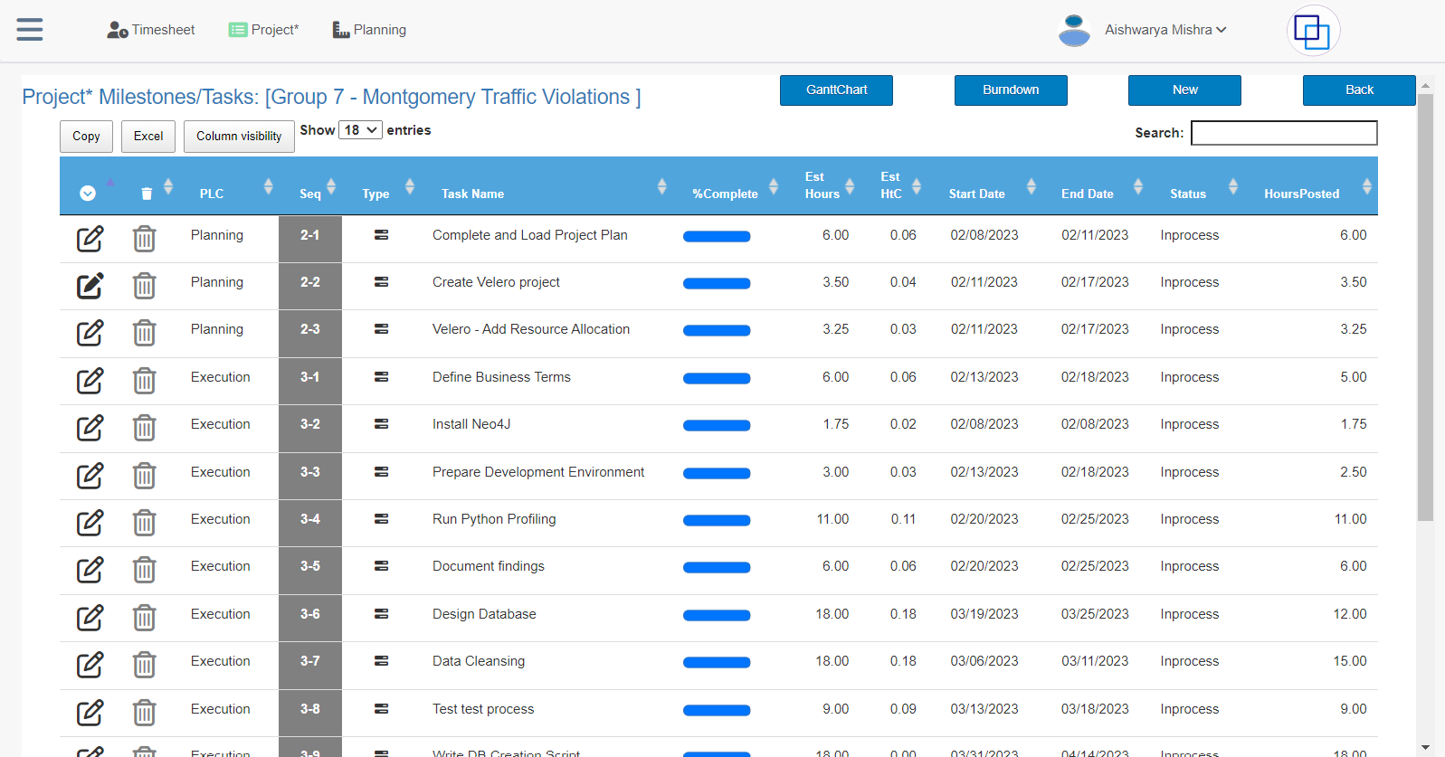

* + Resource Allocation

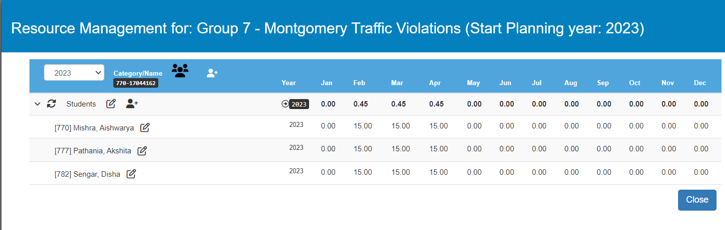

* + Timesheet

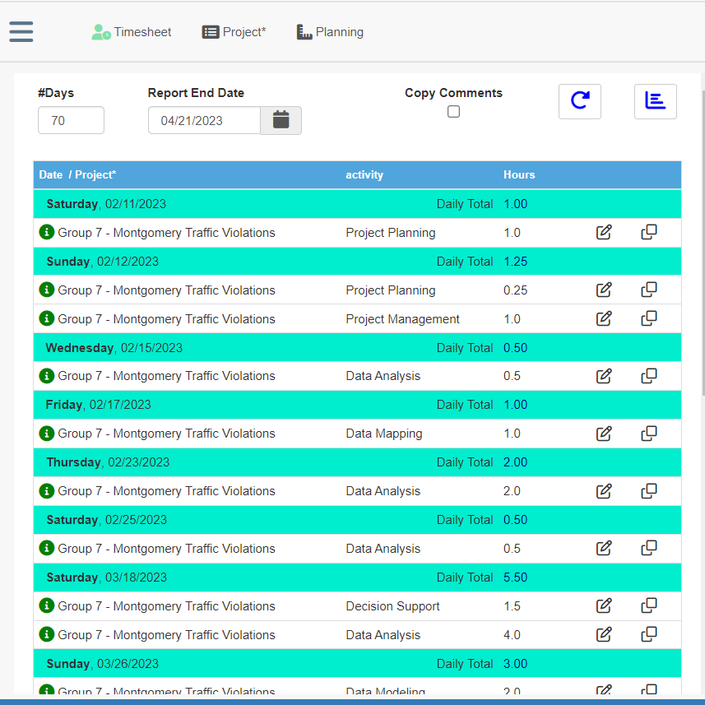

* + Issues & Risks

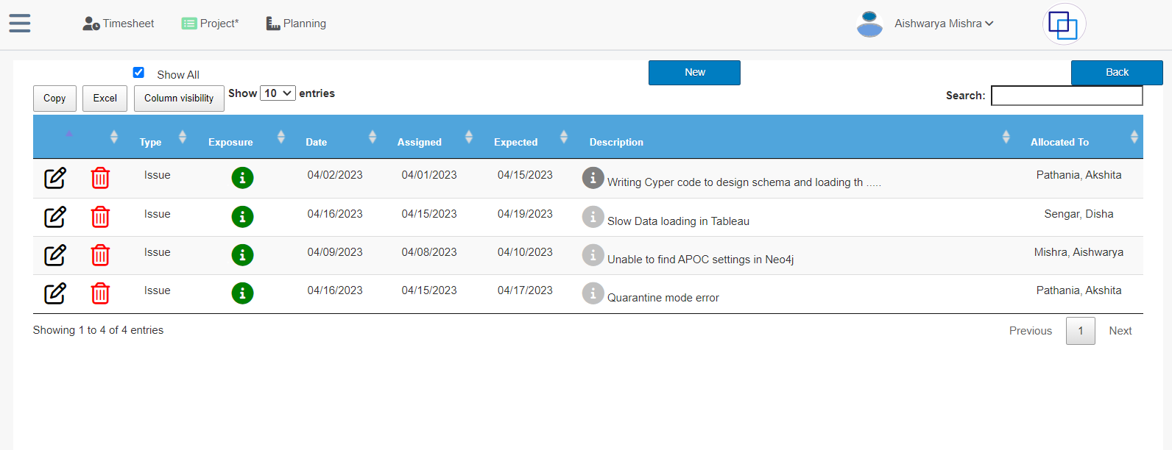

### Visualization Deliverables

* Who is using this dashboard and how do they benefit from your dashboard?

The Analytics Department of the Montgomery County Police Department will utilize the dashboard as a powerful tool to enhance their ability to prevent traffic violations. This dashboard will provide critical insights and data analysis, empowering the department to make informed decisions and take proactive measures to prevent traffic violations in the future. By leveraging the dashboard's capabilities, the department will be able to identify trends and patterns, allowing them to suggest targeted interventions to mitigate potential traffic violations. Ultimately, this will be a valuable asset to the Police Department, helping them to maintain public safety and reduce traffic-related incidents.

* What value would be generated using this dashboard?

The dashboard will prove instrumental in enabling the department to gain a deeper understanding of the underlying causes of traffic violations, as well as the various factors that contribute to their occurrence. By analyzing this data, the department can identify patterns and trends, and use this information to develop targeted interventions aimed at preventing future violations. Additionally, the department can use the dashboard to raise awareness among drivers about best practices for mitigating the occurrence of traffic violations, which is critical to ensuring the safety of all road users. Ultimately, by leveraging the insights provided by the dashboard, the department can take proactive steps to improve road safety and reduce the frequency of traffic violations in the community.

* What data are used for dimensions and columns are used for measurement?

**Dimensions** -Belts, Personal Injury ,Fatal ,Property Damage ,Commercial Vehicle ,HAZMAT, Seq_ID,Agency,Subagency,Commercial Vehicle,Alcohol,Work Zone, Search Conducted,Search Disposition,Search Outcome,Search Reason,Search Type,Search Arrest Reason ,VehicleType,Year,Violation Type,Article,Gender,Arrest Type,Geolocation  
**Measures** – Year ,Row Number

* Did you generate any new dimensions?

Yes, generating a 'Row Number' dimension was a crucial step in data preparation since there was no unique identifier for each record in the dataset. Without a unique identifier, it would have been challenging to accurately track individual records, and it could have led to potential errors during analysis.

### OTHER DELIVERABLES

We have added all project-related files, including Dataset, Jupyter Notebook,Vision Diagram, Cypher code, Neo4j schema snippets showing nodes and relationships, Snippets from Velero and Tableau Worksheet, in the submission file.

# Documentation

## Vision Diagram

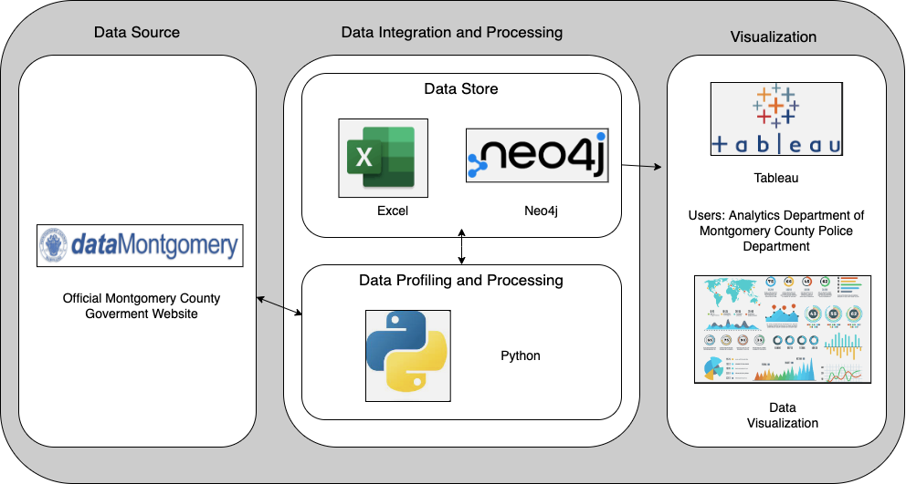

## Data Description, Data Profiling, Data Pre-processing

**Dataset Description:**

* The dataset contains traffic violation information from all electronic traffic violations issued in the County from 2012-2023

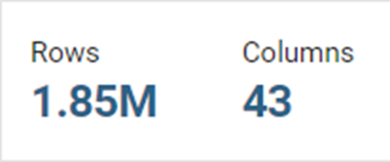

**Data Profiling-**

We used different Python Libraries including **Pandas, Matplotlib and Seaborn** for data profiling.

Following is the snippet showing overview of our data which we generated using Pandas Profiler

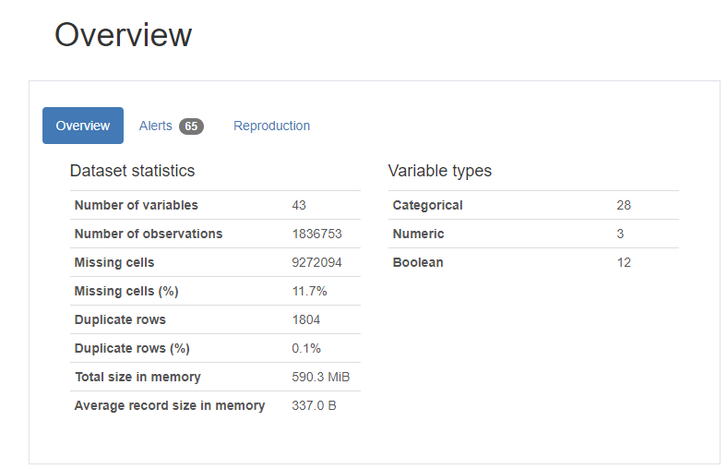

**Correlation** –

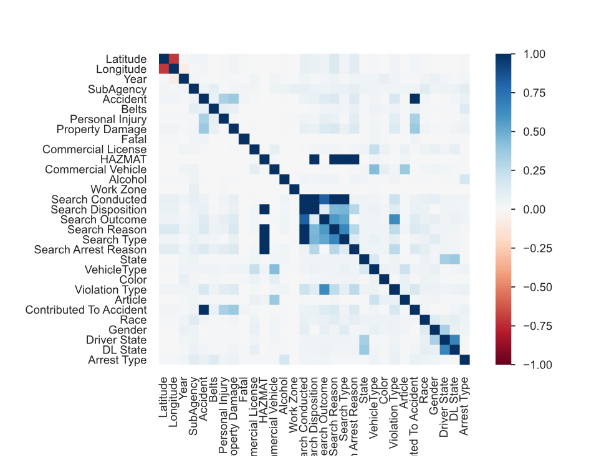

We also used different Python inbuilt functions to examine the data

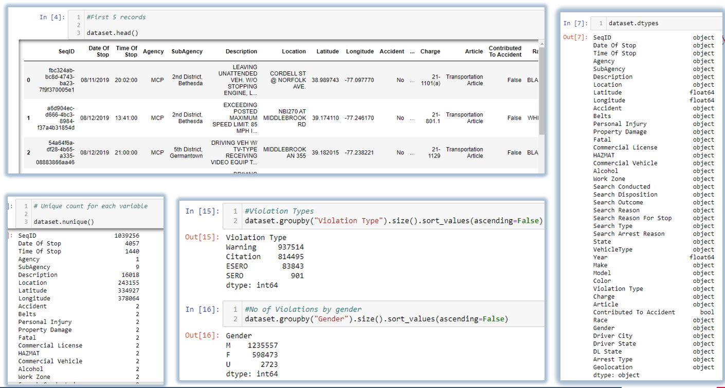

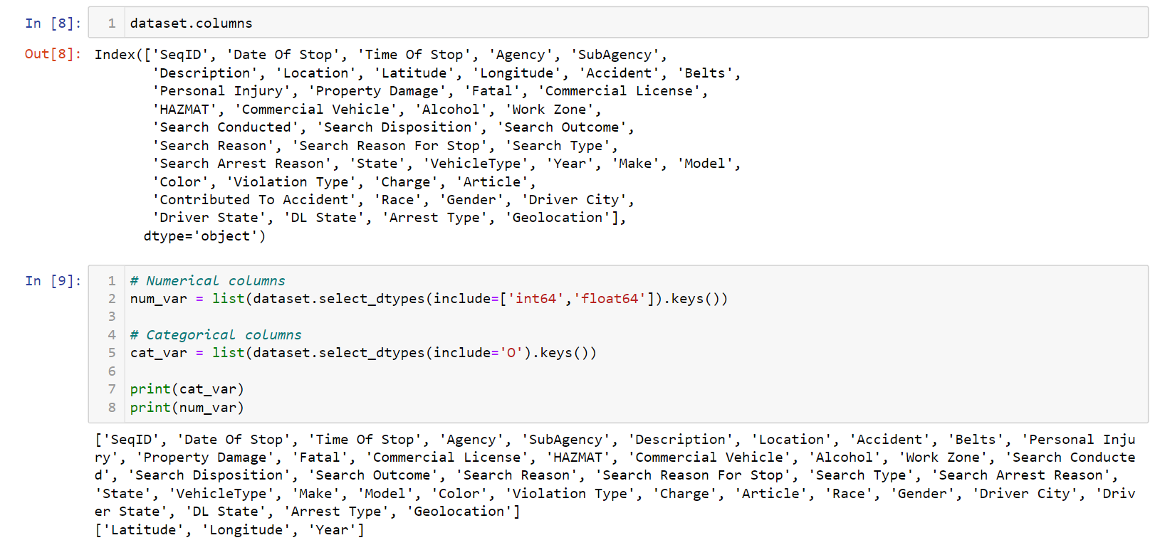

Missing Values- To handle missing values we substituted them with ‘Unknown’ since it was not appropriate to fill them with values. We did this for all the Boolean columns.

Following is the Bar graph showing the count of missing values in the original dataset .

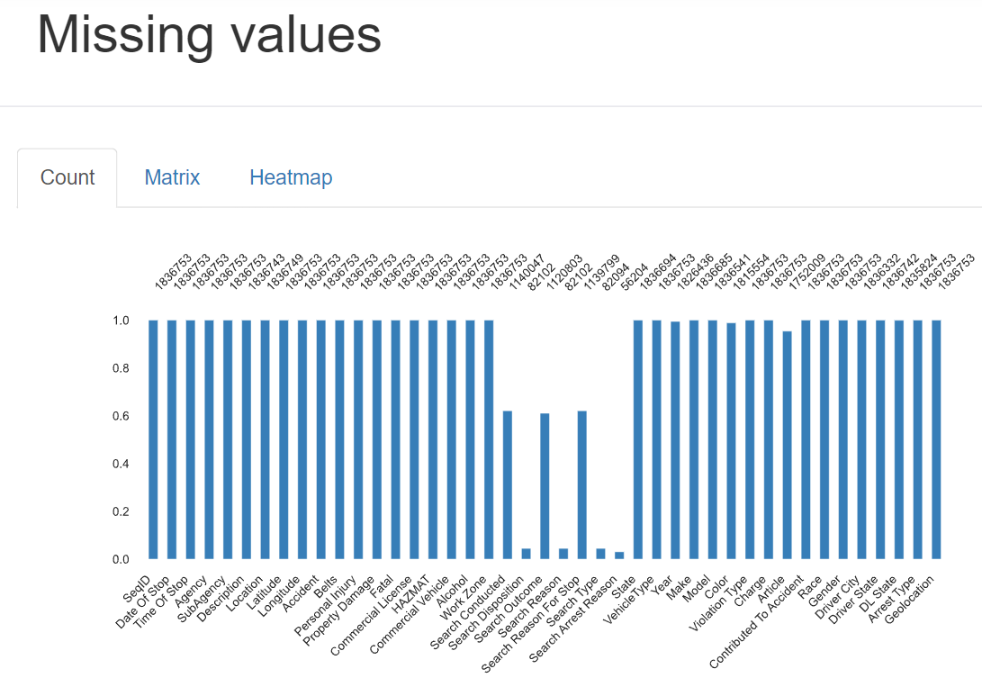

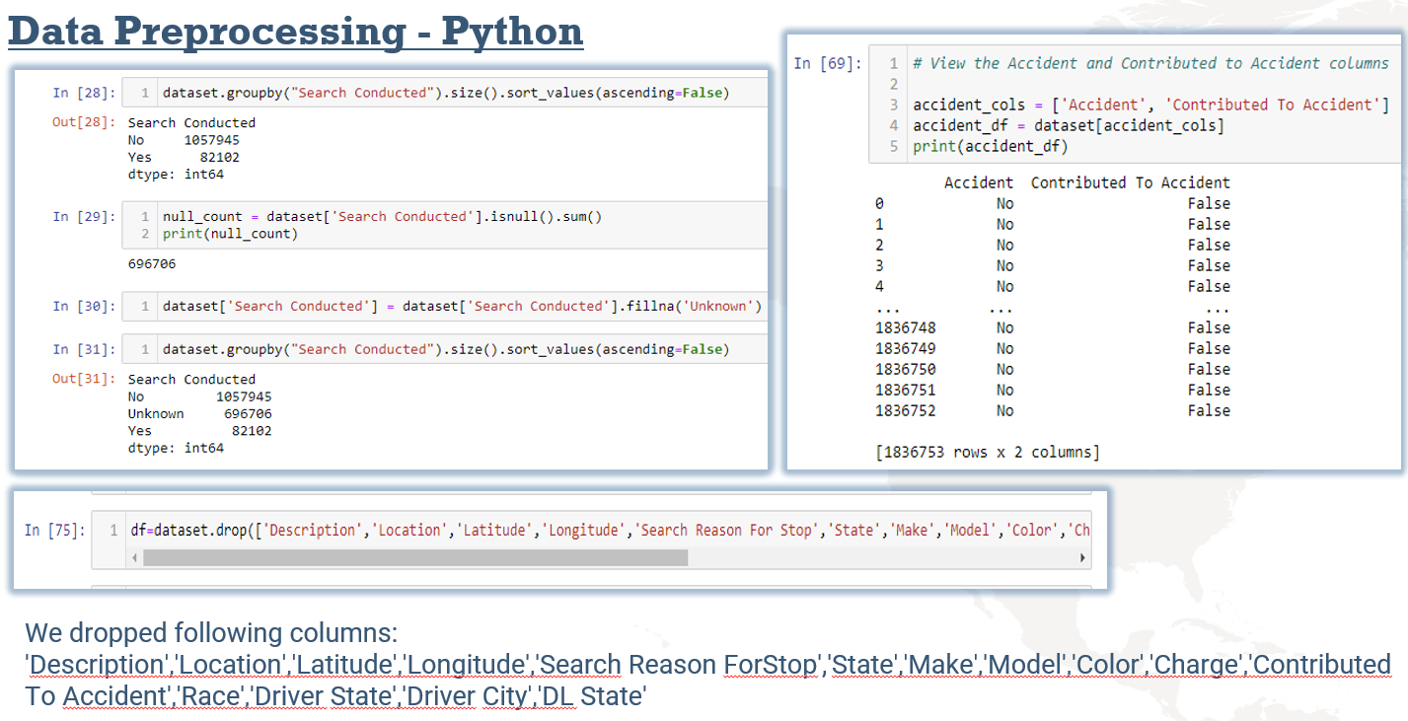

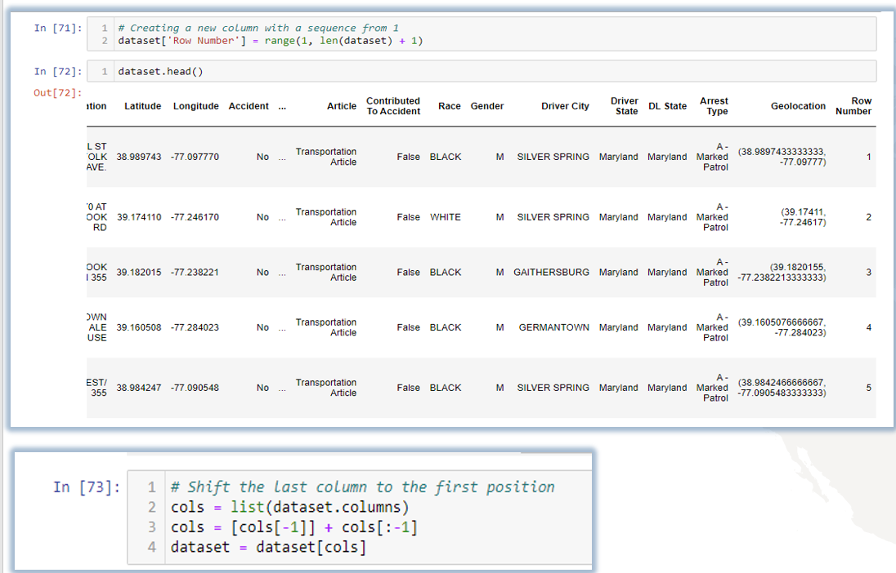

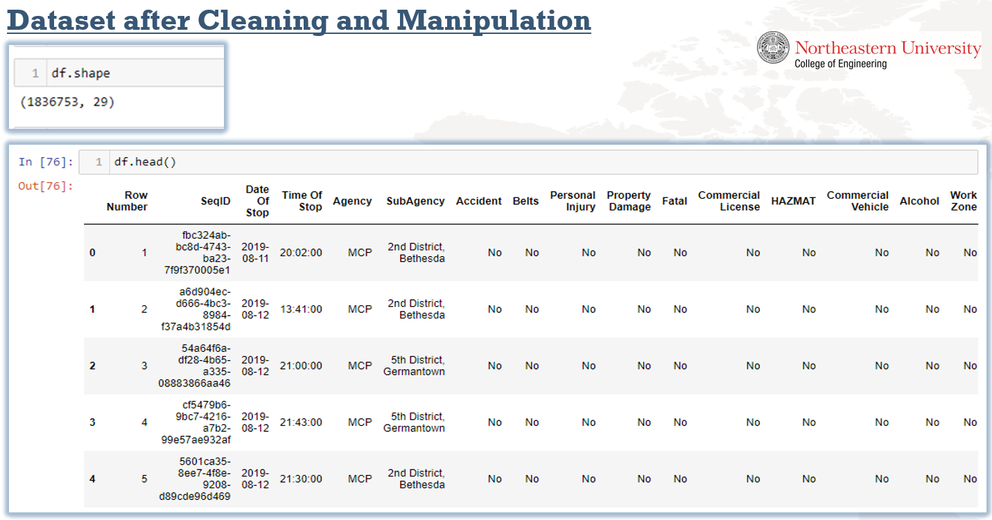

We generated cleaned dataset using Python, which was now ready to be fed into the Neo4j database

## Database Installation

Neo4j is a popular graph database management system that allows users to store, manage and query graph data. It is based on the property graph model, where data is represented as nodes, relationships, and properties. Nodes represent entities, relationships represent the connections between entities, and properties represent the attributes of entities and relationships.  
  
To start a Neo4j database, you need to first download and install the Neo4j Desktop application. Neo4j can be downloaded from <https://neo4j.com/download/>  
  
Once you have installed the Neo4j Desktop, follow these steps to create and start a new database:

1. Open the Neo4j Desktop application and log in to your Neo4j account.
2. Click the "New Project" button to create a new project.
3. Provide a name for your project and click "Create Project".
4. Then click “Create a new database”
5. Choose the desired version of Neo4j and name your database. You can also configure additional settings, such as the database location on your device.
6. Click "Create" to generate your new database.
7. Once the database is created, select the "Start" button to initiate the database.
8. The database will start running, and you can access it using the Neo4j browser by clicking "Open".

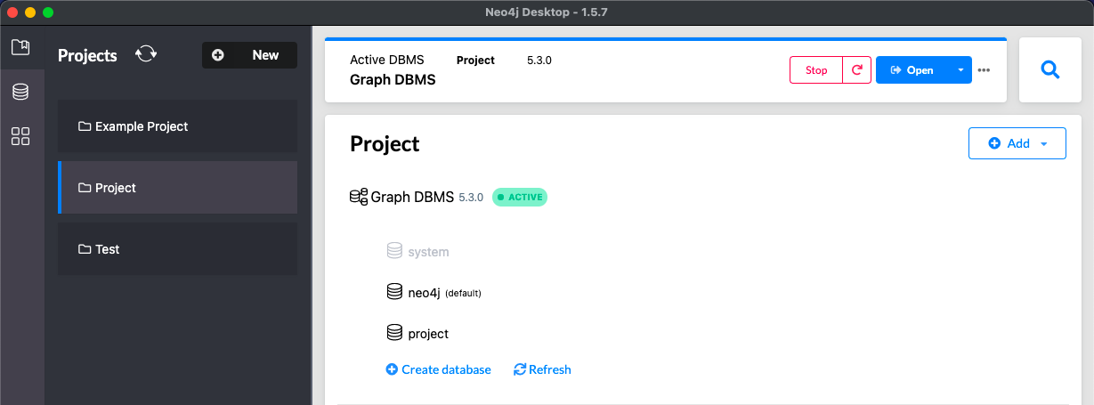

## Data Mapping and Integration

**Data Model**

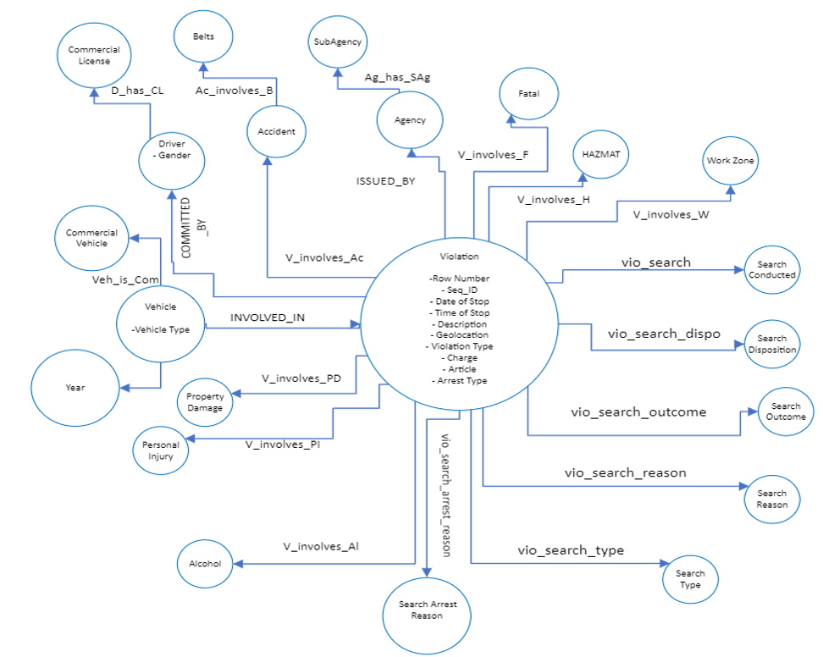

To create this model in database use the following Cypher Script:  
  
**// Defining Unique constraints for database**

CREATE CONSTRAINT FOR (v: Violation) REQUIRE v.row_number IS UNIQUE;

CREATE CONSTRAINT FOR (veh: VehicleType) REQUIRE veh.vehicle_type IS UNIQUE;

CREATE CONSTRAINT FOR (vy: Year) REQUIRE vy.year IS UNIQUE;

CREATE CONSTRAINT FOR (cv: CommercialVehicle) REQUIRE cv.commercial_vehicle IS UNIQUE;

CREATE CONSTRAINT FOR (g: Gender) REQUIRE g.gender IS UNIQUE;

CREATE CONSTRAINT FOR (cl: CommercialLicense) REQUIRE cl.commercial_license IS UNIQUE;

CREATE CONSTRAINT FOR (ac: Accident) REQUIRE ac.accident IS UNIQUE;

CREATE CONSTRAINT FOR (b: Belts) REQUIRE b.belts IS UNIQUE;

CREATE CONSTRAINT FOR (ag: Agency) REQUIRE ag.agency IS UNIQUE;

CREATE CONSTRAINT FOR (sag: SubAgency) REQUIRE sag.sub_agency IS UNIQUE;

CREATE CONSTRAINT FOR (f: Fatal) REQUIRE f.fatal IS UNIQUE;

CREATE CONSTRAINT FOR (h: Hazmat) REQUIRE h.hazmat IS UNIQUE;

CREATE CONSTRAINT FOR (sc:SearchConducted) REQUIRE sc.search_conducted IS UNIQUE;

CREATE CONSTRAINT FOR (st:SearchType) REQUIRE st.search_type IS UNIQUE;

CREATE CONSTRAINT FOR (sr:SearchReason) REQUIRE sr.search_reason IS UNIQUE;

CREATE CONSTRAINT FOR (so:SearchOutcome) REQUIRE so.search_outcome IS UNIQUE;

CREATE CONSTRAINT FOR (sd:SearchDisposition) REQUIRE sd.search_disposition IS UNIQUE;

CREATE CONSTRAINT FOR (sar:SearchArrestReason) REQUIRE sar.search_arrest_reason IS UNIQUE;

CREATE CONSTRAINT FOR (wz:WorkZone) REQUIRE wz.work_zone IS UNIQUE;

CREATE CONSTRAINT FOR (al:Alcohol) REQUIRE al.alcohol IS UNIQUE;

CREATE CONSTRAINT FOR (pi:PersonalInjury) REQUIRE pi.personal_injury IS UNIQUE;

CREATE CONSTRAINT FOR (pd:PropertyDamage) REQUIRE pd.personal_damage IS UNIQUE;

**Creating Nodes and loading data in the database-**

**//Creating Violation Node**

:auto LOAD CSV WITH HEADERS FROM 'file:///ViolationDataset.csv' AS row

With row limit 1

CREATE (v: Violation {row_number: row.`Row Number`,

seq_id:row.SeqID,

date_of_stop:row.`Date Of Stop`,

time_of_stop:row.`Time Of Stop`,

geolocation:row.Geolocation,

violation_type:row.`Violation Type`,

article:row.Article,

arrest_type:row.`Arrest Type`})

**// Loading Violation Node**

:auto LOAD CSV With HEADERS FROM 'file:///ViolationDataset.csv' AS row with row where row.`Row Number` is not null

Call {

With row

MERGE

(v:Violation{row_number: row.`Row Number`})

ON CREATE SET v.seq_id=row.SeqID,

v.date_of_stop=row.`Date Of Stop`,

v.time_of_stop=row.`Time Of Stop`,

v.geolocation=row.Geolocation,

v.violation_type=row.`Violation Type`,

v.article=row.Article,

v.arrest_type=row.`Arrest Type`

} IN TRANSACTIONS OF 500 ROWS;

**//Creating Vehicle Type Node**

:auto LOAD CSV WITH HEADERS FROM 'file:///ViolationDataset.csv' AS row

With row limit 1

CREATE (veh: VehicleType {vehicle_type: row.VehicleType})

**// Loading Data into the Vehicle Type Node**

:auto LOAD CSV WITH HEADERS FROM 'file:///ViolationDataset.csv' AS row with row where row.VehicleType is not null

CALL {

WITH row

MERGE (veh: VehicleType {vehicle_type: row.VehicleType})

} IN TRANSACTIONS OF 500 ROWS;

**// Creating Year Node**

:auto LOAD CSV WITH HEADERS FROM 'file:///ViolationDataset.csv' AS row

With row limit 1

CREATE (vy: Year {year: row.Year})

**// Loading Data into the Year Node**

:auto LOAD CSV WITH HEADERS FROM 'file:///ViolationDataset.csv' AS row with row where row.Year is not null

CALL {

WITH row

MERGE (vy: Year {year: row.Year})

} IN TRANSACTIONS OF 500 ROWS;

**// Creating Commercial Vehicle Node**

:auto LOAD CSV WITH HEADERS FROM 'file:///ViolationDataset.csv' AS row

With row limit 1

CREATE (cv: CommercialVehicle {commercial_vehicle: row.`Commercial Vehicle`})

**// Loading Data into the Commercial Vehicle Node**

:auto LOAD CSV WITH HEADERS FROM 'file:///ViolationDataset.csv' AS row with row where row.`Commercial Vehicle` is not null

CALL {

WITH row

MERGE (cv: CommercialVehicle {commercial_vehicle: row.`Commercial Vehicle`})

} IN TRANSACTIONS OF 500 ROWS;

**// Creating Gender Node**

:auto LOAD CSV WITH HEADERS FROM 'file:///ViolationDataset.csv' AS row

With row limit 1

CREATE (g: Gender {gender: row.Gender})

**// Loading Data into the Gender Node**

:auto LOAD CSV WITH HEADERS FROM 'file:///ViolationDataset.csv' AS row with row where row.Gender is not null

CALL {

WITH row

MERGE (g: Gender {gender: row.Gender})

} IN TRANSACTIONS OF 500 ROWS;

**// Creating Commercial License Node**

:auto LOAD CSV WITH HEADERS FROM 'file:///ViolationDataset.csv' AS row

With row limit 1

CREATE (cl: CommercialLicense {commercial_license: row.`Commercial License`})

**// Loading Data into the Commercial License Node**

:auto LOAD CSV WITH HEADERS FROM 'file:///ViolationDataset.csv' AS row with row where row.`Commercial License` is not null

CALL {

WITH row

MERGE (cl: CommercialLicense {gender: row.`Commercial License`})

} IN TRANSACTIONS OF 500 ROWS;

**// Creating Accident Node**

:auto LOAD CSV WITH HEADERS FROM 'file:///ViolationDataset.csv' AS row

With row limit 1

CREATE (ac: Accident {accident: row.Accident})

**// Loading Data into the Accident Node**

:auto LOAD CSV WITH HEADERS FROM 'file:///ViolationDataset.csv' AS row with row where row.Accident is not null

CALL {

WITH row

MERGE (ac: Accident {accident: row.Accident})

} IN TRANSACTIONS OF 500 ROWS;

**// Creating Belts Node**

:auto LOAD CSV WITH HEADERS FROM 'file:///ViolationDataset.csv' AS row

With row limit 1

CREATE (b: Belts {belts: row.Belts})

**// Loading Data into the Belts Node**

:auto LOAD CSV WITH HEADERS FROM 'file:///ViolationDataset.csv' AS row with row where row.Belts is not null

CALL {

WITH row

MERGE (b: Belts {belts: row.Belts})

} IN TRANSACTIONS OF 500 ROWS;

**// Creating Agency Node**

:auto LOAD CSV WITH HEADERS FROM 'file:///ViolationDataset.csv' AS row

With row limit 1

CREATE (ag: Agency {agency: row.Agency})

**// Loading Data into the Agency Node**

:auto LOAD CSV WITH HEADERS FROM 'file:///ViolationDataset.csv' AS row with row where row.Agency is not null

CALL {

WITH row

MERGE (ag: Agency {agency: row.Agency})

} IN TRANSACTIONS OF 500 ROWS;

**// Creating SubAgency Node**

:auto LOAD CSV WITH HEADERS FROM 'file:///ViolationDataset.csv' AS row

With row limit 1

CREATE (sag: SubAgency {subagency: row.SubAgency})

**// Loading Data into the SubAgency Node**

:auto LOAD CSV WITH HEADERS FROM 'file:///ViolationDataset.csv' AS row with row where row.SubAgency is not null

CALL {

WITH row

MERGE (sag: SubAgency {subagency: row.SubAgency})

} IN TRANSACTIONS OF 500 ROWS;

**// Creating Fatal Node**

:auto LOAD CSV WITH HEADERS FROM 'file:///ViolationDataset.csv' AS row

With row limit 1

CREATE (f: Fatal {fatal: row.Fatal})

**// Loading Data into the Fatal Node**

:auto LOAD CSV WITH HEADERS FROM 'file:///ViolationDataset.csv' AS row with row where row.Fatal is not null

CALL {

WITH row

MERGE (f: Fatal {fatal: row.Fatal})

} IN TRANSACTIONS OF 500 ROWS;

**// Creating HAZMAT Node**

:auto LOAD CSV WITH HEADERS FROM 'file:///ViolationDataset.csv' AS row

With row limit 1

CREATE (h: Hazmat {hazmat: row.`HAZMAT`})

**// Loading Data into the HAZMAT Node**

:auto LOAD CSV WITH HEADERS FROM 'file:///ViolationDataset.csv' AS row with row where row.`HAZMAT` is not null

CALL {

WITH row

MERGE (h: Hazmat {hazmat: row.`HAZMAT`})

} IN TRANSACTIONS OF 500 ROWS;

**// Creating Search Conducted Node**

:auto LOAD CSV WITH HEADERS FROM 'file:///ViolationDataset.csv' AS row

With row limit 1

CREATE (sc: SearchConducted {search_conducted: row.`Search Conducted`})

**// Loading Data into the Search Conducted Node**

:auto LOAD CSV WITH HEADERS FROM 'file:///ViolationDataset.csv' AS row with row where row.`Search Conducted` is not null

CALL {

WITH row

MERGE (sc: SearchConducted {search_conducted: row.`Search Conducted`})

} IN TRANSACTIONS OF 500 ROWS;

**//Creating SearchType Node**

:auto LOAD CSV WITH HEADERS FROM 'file:///ViolationDataset.csv' AS row

With row limit 1

CREATE (st: SearchType {search_type: row.`Search Type`})

**//Loading SearchType Node**

:auto LOAD CSV WITH HEADERS FROM 'file:///ViolationDataset.csv' AS row with row where row.`Search Type` is not null

CALL {

WITH row

MERGE (st: SearchType {search_type: row.`Search Type`})

} IN TRANSACTIONS OF 500 ROWS;

**// Creating SearchDisposition Node**

LOAD CSV WITH HEADERS FROM 'file:///ViolationDataset.csv' AS row

With row limit 1

CREATE (sd: SearchDisposition {

search_disposition: row.`Search Disposition`})

**//Loading SearchDisposition Node**

:auto LOAD CSV WITH HEADERS FROM 'file:///ViolationDataset.csv' AS row with row where row.`Search Disposition` is not null

CALL {

WITH row

MERGE (sd: SearchDisposition {search_disposition: row.`Search Disposition`})

} IN TRANSACTIONS OF 500 ROWS;

**//Creating SearchArrestReason Node**

LOAD CSV WITH HEADERS FROM 'file:///ViolationDataset.csv' AS row

With row limit 1

CREATE (sar: SearchArrestReason { search_arrest_reason: row.`Search Arrest Reason`})

**//Loading SearchArrestReason Node**

:auto LOAD CSV WITH HEADERS FROM 'file:///ViolationDataset.csv' AS row with row where row.`Search Arrest Reason` is not null

CALL {

WITH row

MERGE (sar: SearchArrestReason { search_arrest_reason: row.`Search Arrest Reason`})

} IN TRANSACTIONS OF 500 ROWS;

**// Creating SearchReason Node**

LOAD CSV WITH HEADERS FROM 'file:///ViolationDataset.csv' AS row

With row limit 1

CREATE (sr: SearchReason {

search_reason: row.`Search Reason`})

**//Loading the SearchReason Node**

:auto LOAD CSV With HEADERS FROM 'file:///ViolationDataset.csv' AS row with row where row.`Search Reason` is not null

CALL{

WITH row

MERGE (sr:SearchReason{

search_reason: row.`Search Reason`})

} IN TRANSACTIONS OF 500 ROWS;

**//Creating SearchOutcome Node**

LOAD CSV WITH HEADERS FROM 'file:///ViolationDataset.csv' AS row

With row limit 1

CREATE (so: SearchOutcome {

search_outcome: row.`Search Outcome`})

**//Loading the Search Outcome Node**

:auto LOAD CSV With HEADERS FROM 'file:///ViolationDataset.csv' AS row with row where row.`Search Outcome` is not null

CALL{

WITH row

MERGE (so: SearchOutcome {

search_outcome: row.`Search Outcome`})

} IN TRANSACTIONS OF 500 ROWS;

**// Creating Work Zone node**

LOAD CSV WITH HEADERS FROM 'file:///ViolationDataset.csv' AS row

With row limit 1

CREATE (wz: WorkZone {

work_zone: row.`Work Zone`})

**//Load WorkZone Node**

:auto LOAD CSV With HEADERS FROM 'file:///ViolationDataset.csv' AS row with row where row.`Work Zone` is not null

CALL{

WITH row

MERGE (wz: WorkZone {

work_zone: row.`Work Zone`})

} IN TRANSACTIONS OF 500 ROWS;

**// Creating Alcohol Node**

LOAD CSV WITH HEADERS FROM 'file:///ViolationDataset.csv' AS row

With row limit 1

CREATE (al: Alcohol {

alcohol: row.Alcohol})

**//Loading Alcohol Node**

:auto LOAD CSV With HEADERS FROM 'file:///ViolationDataset.csv' AS row with row where row.Alcohol is not null

CALL{

WITH row

MERGE (al: Alcohol {

alcohol: row.Alcohol})

} IN TRANSACTIONS OF 500 ROWS;

**// Creating Personal Injury Node**

LOAD CSV WITH HEADERS FROM 'file:///ViolationDataset.csv' AS row

With row limit 1

CREATE (pi: PersonalInjury {

personal_injury: row.`Personal Injury`})

**//Loading PersonalInjury Node**

:auto LOAD CSV With HEADERS FROM 'file:///ViolationDataset.csv' AS row with row where row.`Personal Injury` is not null

CALL{

WITH row

MERGE (pi: PersonalInjury {

personal_injury: row.`Personal Injury`})

} IN TRANSACTIONS OF 500 ROWS;

**// Creating Property Damage Node**

LOAD CSV WITH HEADERS FROM 'file:///ViolationDataset.csv' AS row

With row limit 1

CREATE (pd: PropertyDamage {

property_damage: row.`Property Damage`})

**//Loading PropertyDamage Node**

:auto LOAD CSV With HEADERS FROM 'file:///ViolationDataset.csv' AS row with row where row.`Property Damage` is not null

CALL{

WITH row

MERGE (pd: PropertyDamage {

property_damage: row.`Property Damage`})

} IN TRANSACTIONS OF 500 ROWS;

**// RELATIONSHIP between VIOLATION & SEARCH CONDUCTED**

LOAD CSV With HEADERS FROM 'file:///ViolationDataset.csv' AS row

MATCH (v:Violation), (sc:SearchConducted)

WHERE v.row_number = row.`Row Number` AND sc.search_conducted = row.`Search Conducted`

CREATE (v)-[:Vio_search]->(sc);

**// RELATIONSHIP between VIOLATION & SEARCH OUTCOME**

LOAD CSV With HEADERS FROM 'file:///ViolationDataset.csv' AS row

MATCH (v:Violation), (so:SearchOutcome)

WHERE v.row_number = row.`Row Number` AND so.search_outcome = row.`Search Outcome`

CREATE (v)-[:Vio_search_outcome]->(so);

**// RELATIONSHIP between VIOLATION & WORK ZONE**

LOAD CSV With HEADERS FROM 'file:///ViolationDataset.csv' AS row

MATCH (v:Violation), (wz:WorkZone)

WHERE v.row_number = row.`Row Number` AND wz.work_zone = row.`Work Zone`

CREATE (v)-[:V_involves_W]->(wz);

**// RELATIONSHIP between VIOLATION & ALCOHOL**

LOAD CSV With HEADERS FROM 'file:///ViolationDataset.csv' AS row

MATCH (v:Violation), (al:Alcohol)

WHERE v.row_number = row.`Row Number` AND al.alcohol = row.Alcohol

CREATE (v)-[:V_involves_Al]->(al);

**// RELATIONSHIP between VIOLATION & PERSONAL INJURY**

LOAD CSV With HEADERS FROM 'file:///ViolationDataset.csv' AS row

MATCH (v:Violation), (pi:PersonalInjury)

WHERE v.row_number = row.`Row Number` AND pi.personal_injury = row.`Personal Injury`

CREATE (v)-[:V_involves_PI]->(pi);

**// RELATIONSHIP between VIOLATION & PROPERTY DAMAGE**

LOAD CSV With HEADERS FROM 'file:///ViolationDataset.csv' AS row

MATCH (v:Violation), (pd:PropertyDamage)

WHERE v.row_number = row.`Row Number` AND pd.property_damage = row.`Property Damage`

CREATE (v)-[:V_involves_PD]->(pd);

**// RELATIONSHIP between VIOLATION & FATAL**

LOAD CSV With HEADERS FROM 'file:///ViolationDataset.csv' AS row

MATCH (v:Violation), (f:Fatal)

WHERE v.row_number = row.`Row Number` AND f.fatal = row.`Fatal`

CREATE (v)-[:V_involves_F]->(f);

**// RELATIONSHIP between VIOLATION & HAZMAT**

LOAD CSV With HEADERS FROM 'file:///ViolationDataset.csv' AS row

MATCH (v:Violation), (h:Hazmat)

WHERE v.row_number = row.`Row Number` AND h.hazmat = row.`HAZMAT`

CREATE (v)-[:V_involves_H]->(h);

**// RELATIONSHIP between VIOLATION & SEARCH DISPOSITION**

LOAD CSV With HEADERS FROM 'file:///ViolationDataset.csv' AS row

MATCH (v:Violation), (sd:SearchDisposition)

WHERE v.row_number = row.`Row Number` AND sd.search_disposition = row.`Search Disposition`

CREATE (v)-[:Vio_search_dispo]->(sd);

**// RELATIONSHIP between VIOLATION & SEARCH REASON**

LOAD CSV With HEADERS FROM 'file:///ViolationDataset.csv' AS row

MATCH (v:Violation), (sr:SearchReason)

WHERE v.row_number = row.`Row Number` AND sr.search_reason = row.`Search Reason`

CREATE (v)-[:Vio_search_reason]->(sr);

**// RELATIONSHIP between VIOLATION & SEARCH TYPE**

LOAD CSV With HEADERS FROM 'file:///ViolationDataset.csv' AS row

MATCH (v:Violation), (st:SearchType)

WHERE v.row_number = row.`Row Number` AND st.search_type = row.`Search Type`

CREATE (v)-[:Vio_search_type]->(st);

**// RELATIONSHIP between VIOLATION & SEARCH ARREST REASON**

LOAD CSV With HEADERS FROM 'file:///ViolationDataset.csv' AS row

MATCH (v:Violation), (sag:SearchArrestReason)

WHERE v.row_number = row.`Row Number` AND sag.search_arrest_reason = row.`Search Arrest Reason`

CREATE (v)-[:Vio_searc_arrest_reason]->(sag);

**// RELATIONSHIP between VIOLATION & Gender**

LOAD CSV With HEADERS FROM 'file:///ViolationDataset.csv' AS row

MATCH (v:Violation), (g:Gender)

WHERE v.row_number = row.`Row Number` AND g.gender = row.`Gender`

CREATE (v)-[:Committed_By]->(g);

**// RELATIONSHIP between VIOLATION & ACCIDENT**

LOAD CSV With HEADERS FROM 'file:///ViolationDataset.csv' AS row

MATCH (v:Violation), (ac:Accident)

WHERE v.row_number = row.`Row Number` AND ac.accident = row.`Accident`

CREATE (v)-[:V_involves_Ac]->(ac);

**// RELATIONSHIP between VIOLATION & AGENCY**

LOAD CSV With HEADERS FROM 'file:///ViolationDataset.csv' AS row

MATCH (v:Violation), (ag:Agency)

WHERE v.row_number = row.`Row Number` AND ag.agency = row.`Agency`

CREATE (v)-[:Issued_By]->(ag);

**// RELATIONSHIP between VEHICLE TYPE & VIOLATION**

LOAD CSV With HEADERS FROM 'file:///ViolationDataset.csv' AS row

MATCH (veh:VehicleType), (v:Violation)

WHERE veh.vehicle_type = row.`VehicleType` AND v.row_number = row.`Row Number`

CREATE (veh)-[:Involved_In]->(v);

**// RELATIONSHIP between VEHICLE TYPE & YEAR**

LOAD CSV With HEADERS FROM 'file:///ViolationDataset.csv' AS row

MATCH (veh:VehicleType), (vy:Year)

WHERE veh.vehicle_type = row.VehicleType AND vy.year = row.Year

CREATE (veh)-[:Veh_year]->(vy);

**// RELATIONSHIP between VEHICLE TYPE & COMMERCIAL VEHICLE**

LOAD CSV With HEADERS FROM 'file:///ViolationDataset.csv' AS row

MATCH (veh:VehicleType), (cv:CommercialVehicle)

WHERE veh.vehicle_type = row.`VehicleType` AND cv.commercial_vehicle = row.`Commercial Vehicle`

CREATE (veh)-[:Veh_is_Com]->(cv);

**// RELATIONSHIP between GENDER & COMMERCIAL LICENSE**

LOAD CSV With HEADERS FROM 'file:///ViolationDataset.csv' AS row

MATCH (g:Gender), (cl:CommercialLicense)

WHERE g.gender = row.`Gender` AND cl.commercial_license = row.`Commercial License`

CREATE (g)-[:D_has_Cl]->(cl);

**// RELATIONSHIP between ACCIDENT & BELTS**

LOAD CSV With HEADERS FROM 'file:///ViolationDataset.csv' AS row

MATCH (ac:Accident), (b:Belts)

WHERE ac.accident = row.`Accident` AND b.belts = row.`Belts`

CREATE (ac)-[:Ac_involves_B]->(b);

**// RELATIONSHIP between AGENCY & SUBAGENCY**

LOAD CSV With HEADERS FROM 'file:///ViolationDataset.csv' AS row

MATCH (ag:Agency), (sag:SubAgency)

WHERE ag.agency = row.`Agency` AND sag.subagency = row.`SubAgency`

CREATE (ag)-[:Ag_has_SAg]->(sag);

**In all, we created 22 nodes and 21 relationships**

For Data Visualization ,we connected Neo4j with Tableau using JDBC Connection:  
  
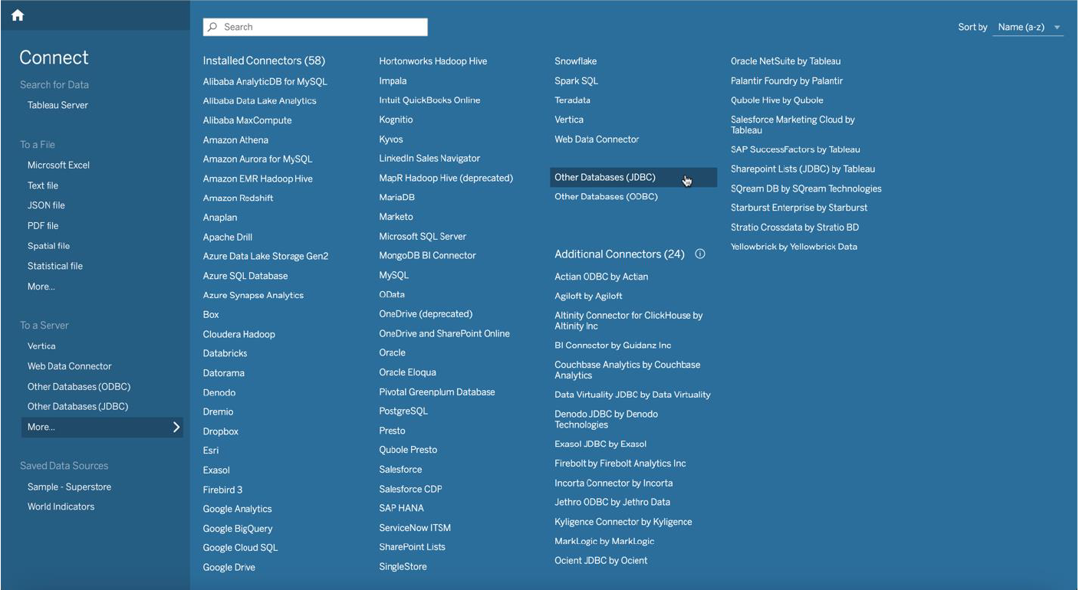

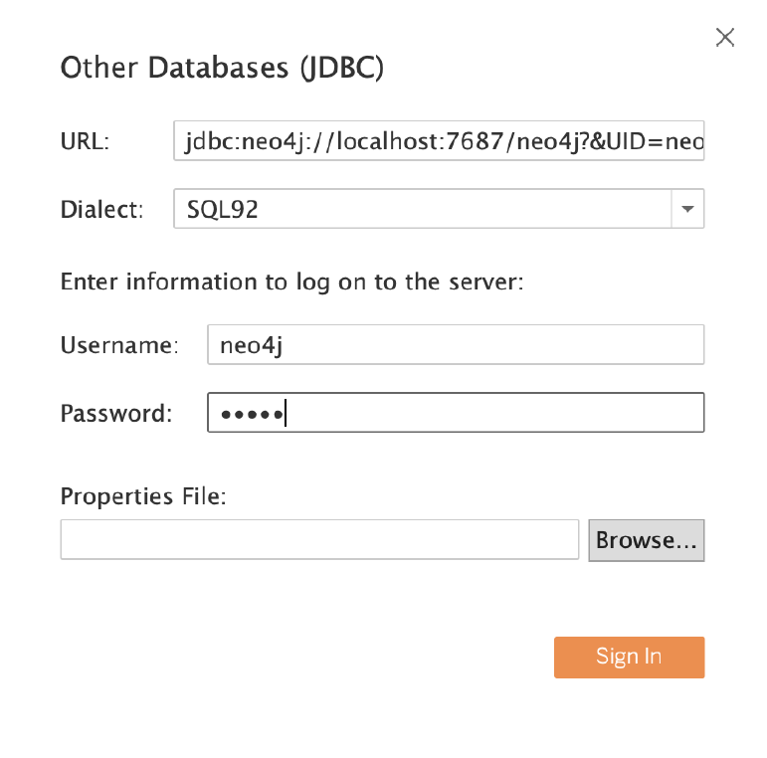

**Neo4j Schema and Node labels-**

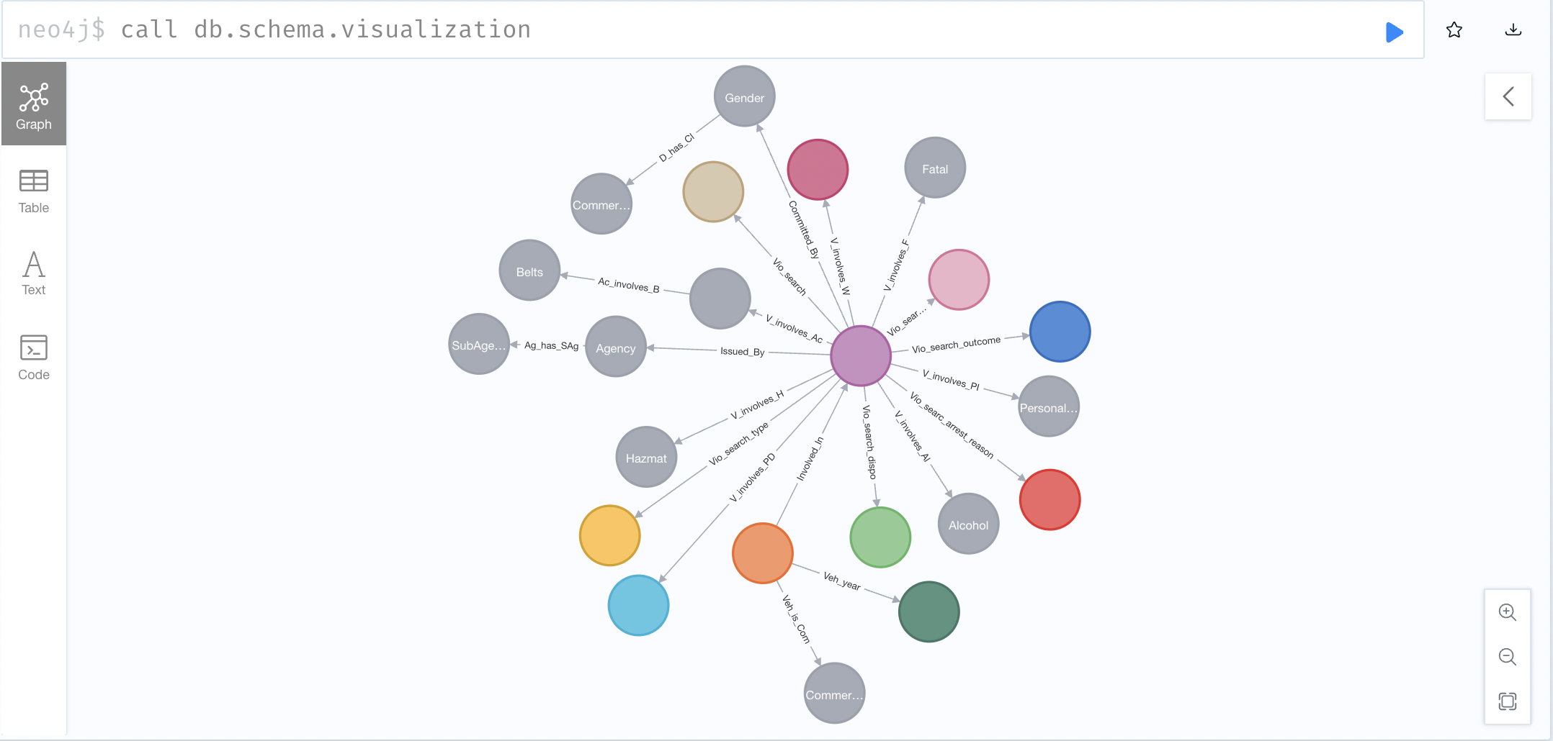

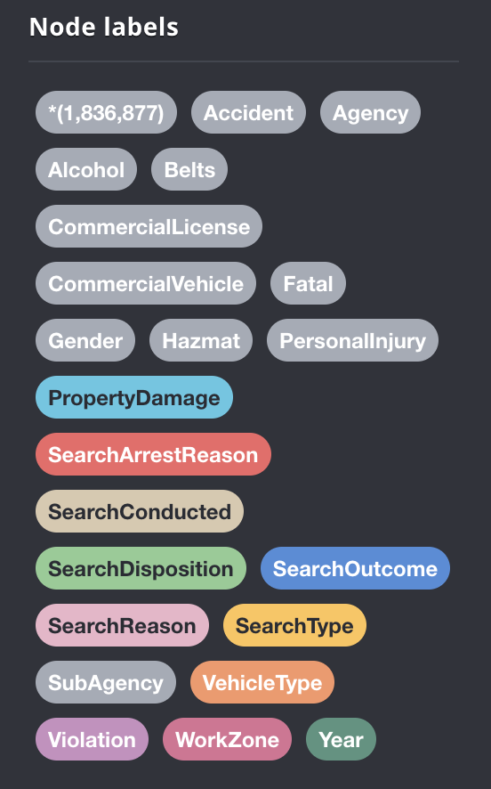

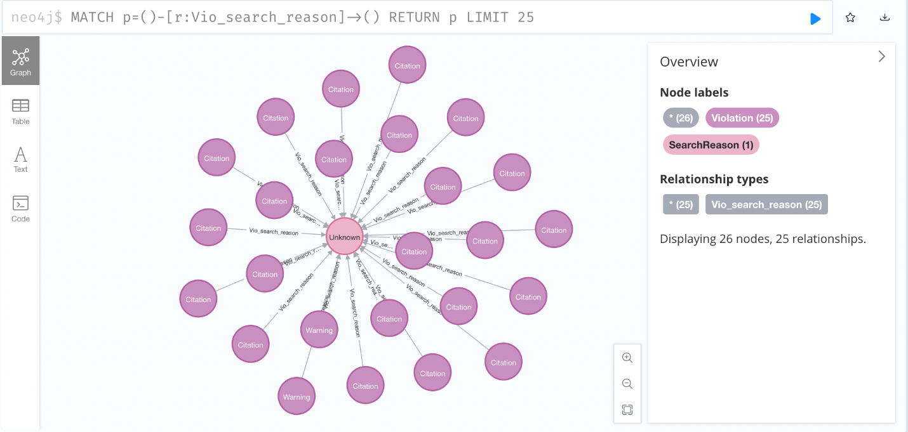

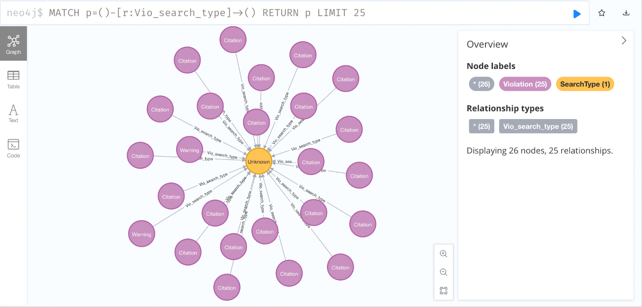

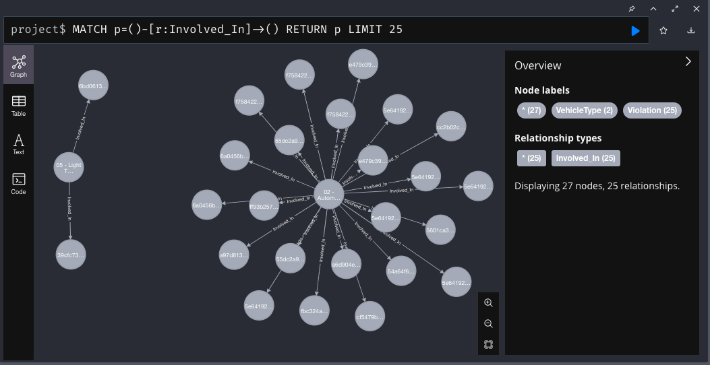

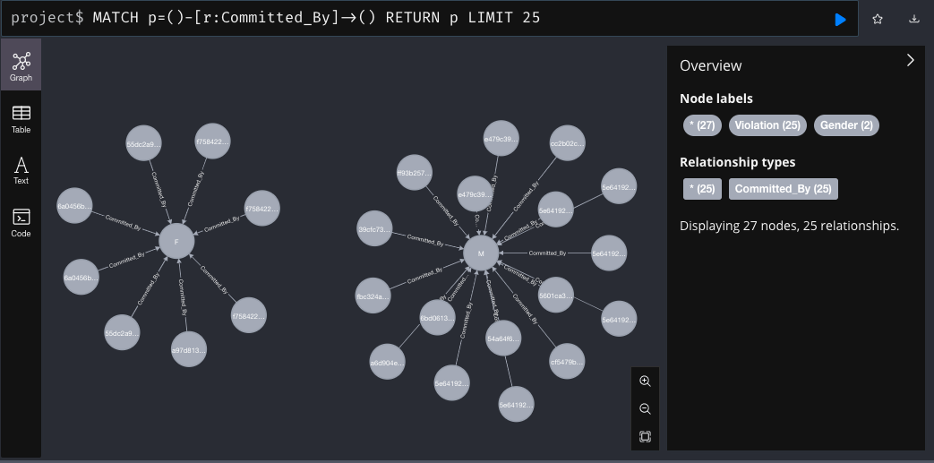

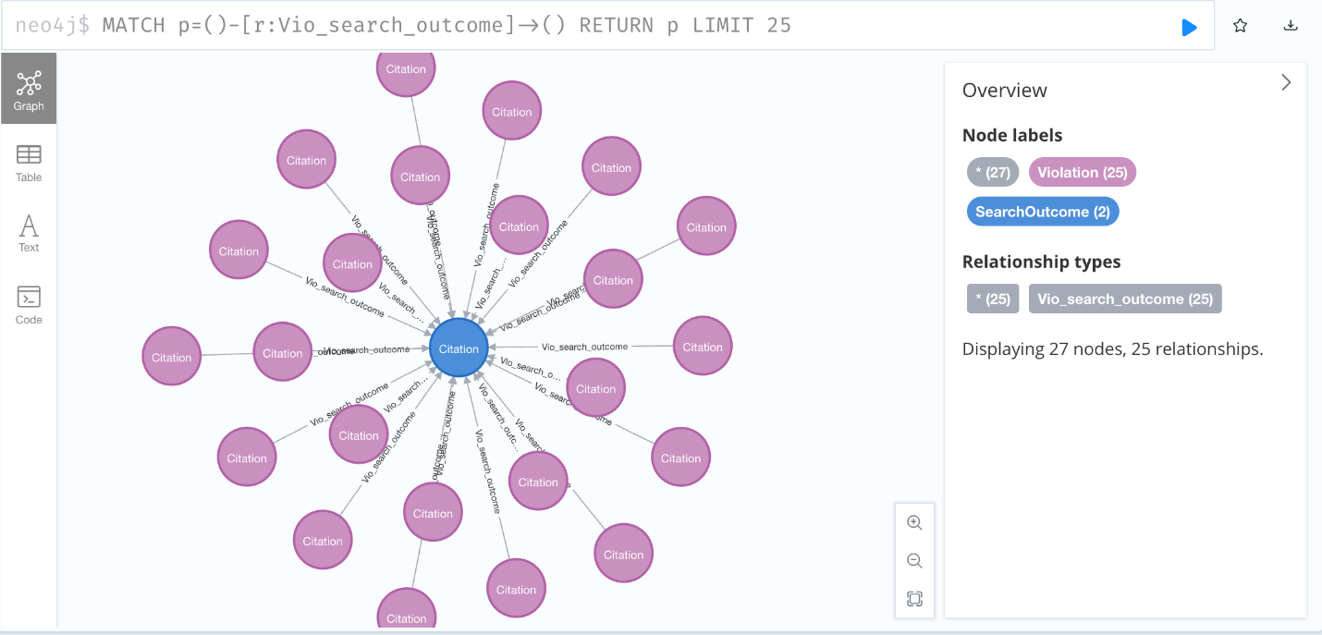

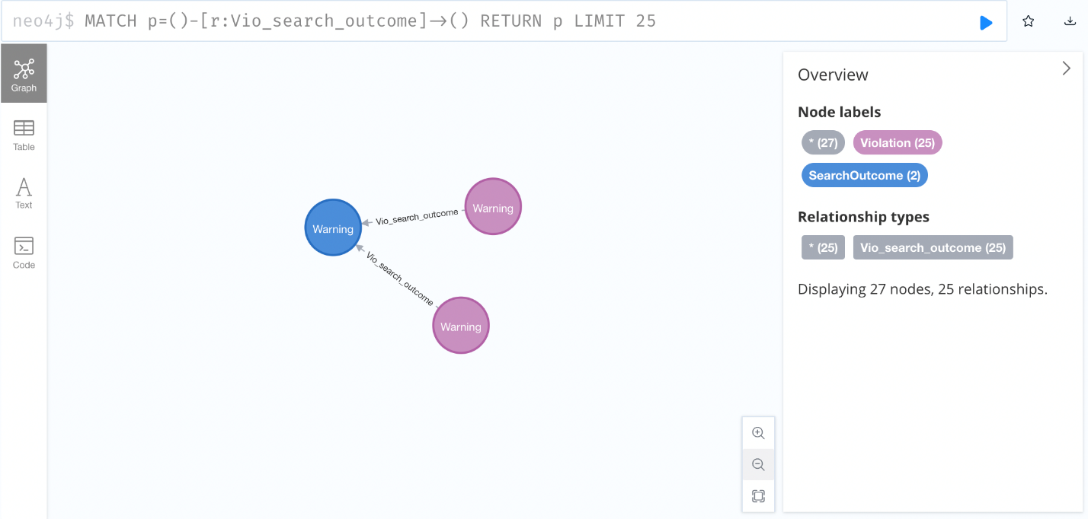

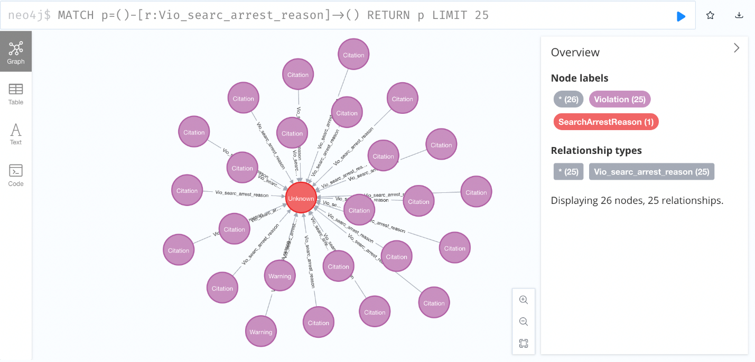

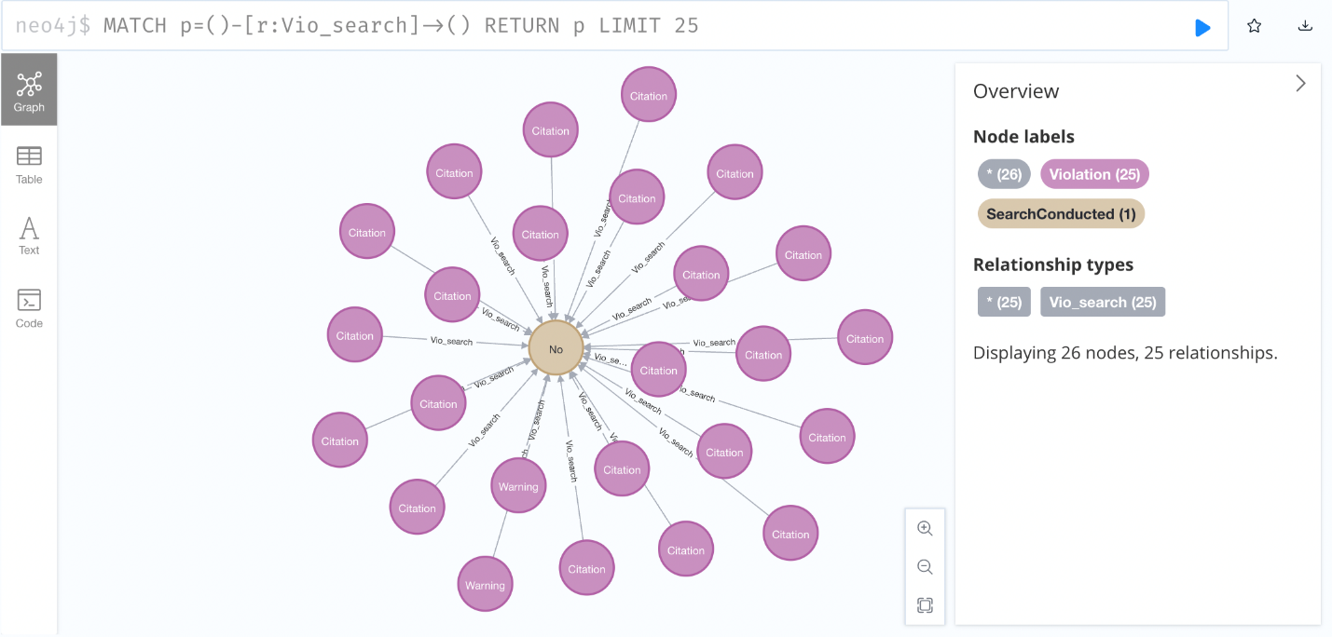

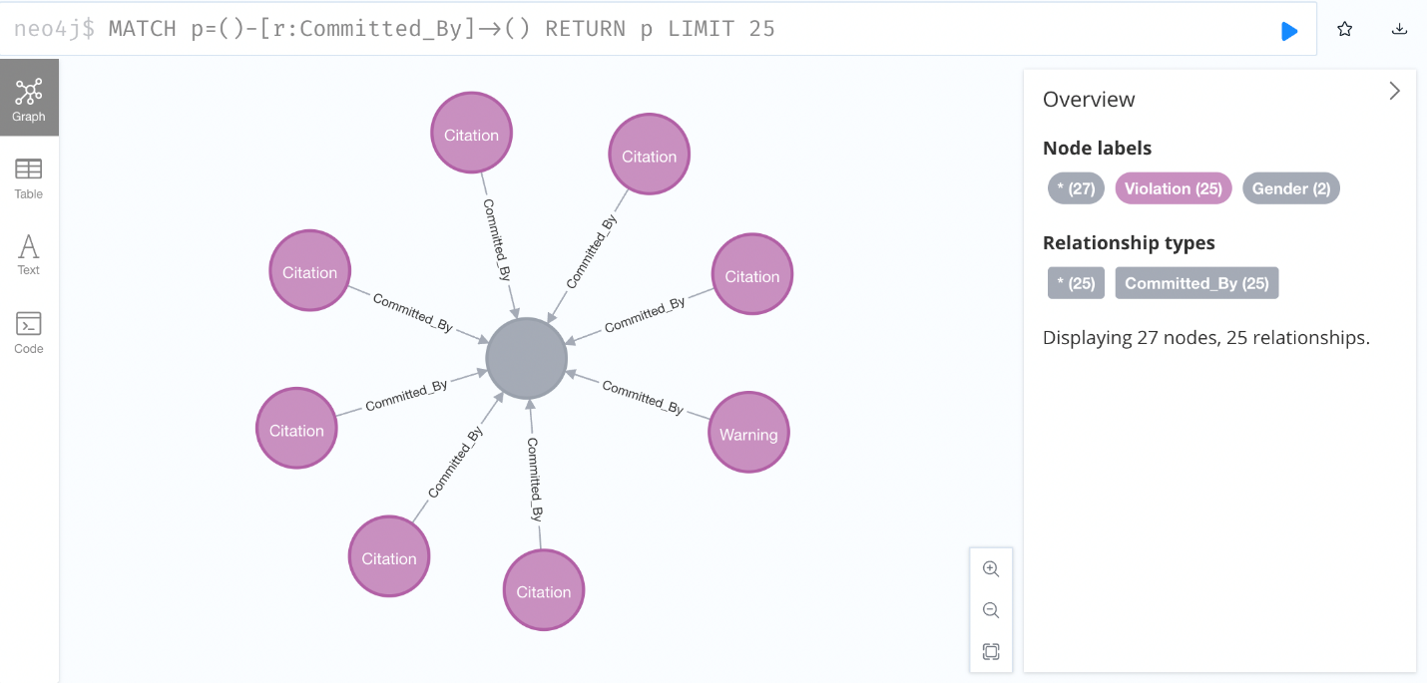

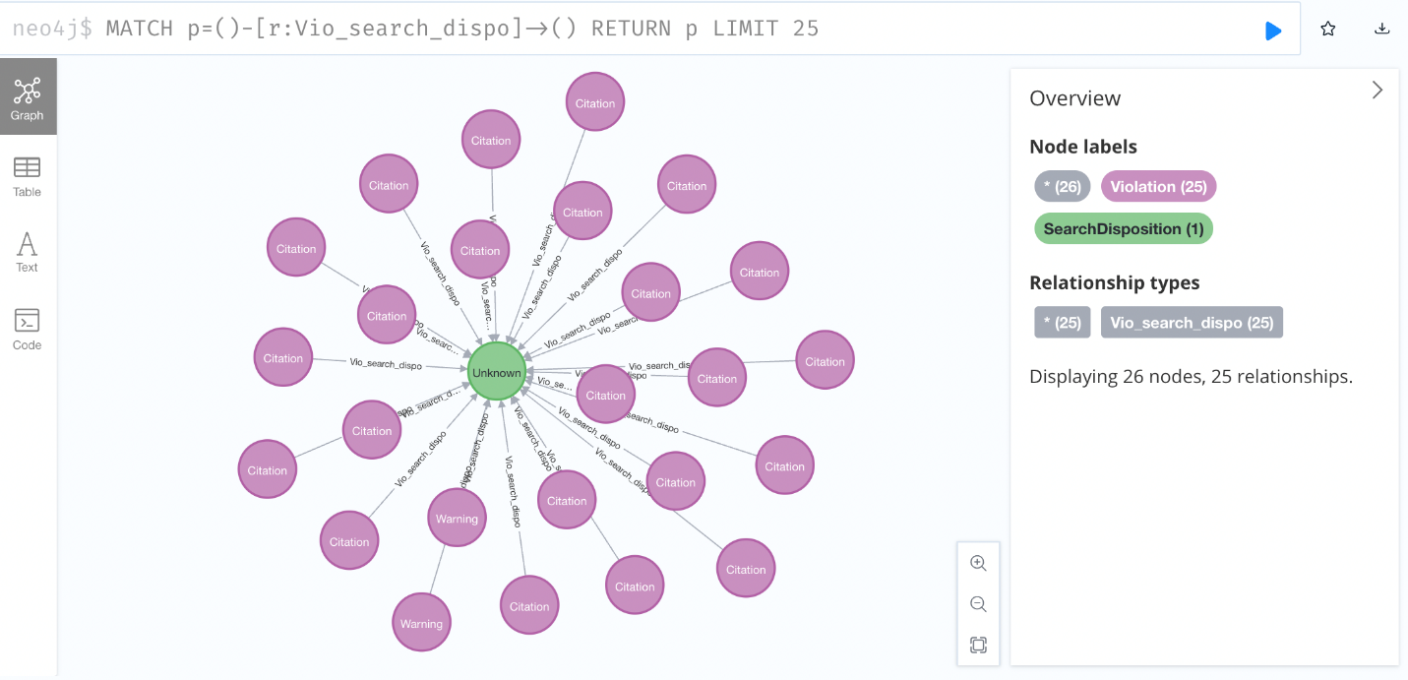

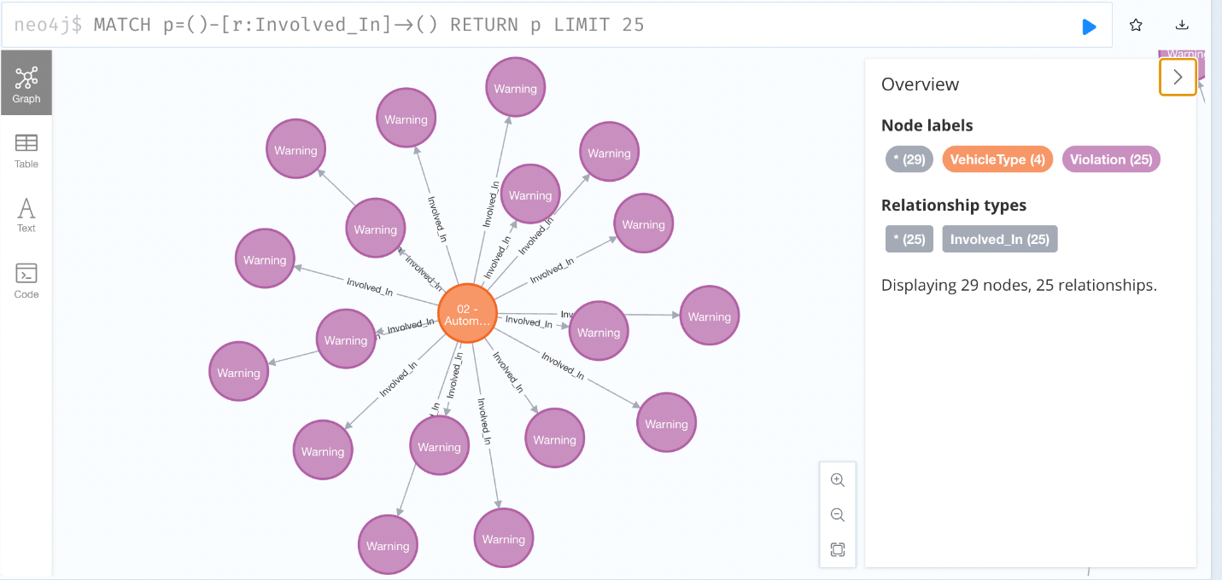

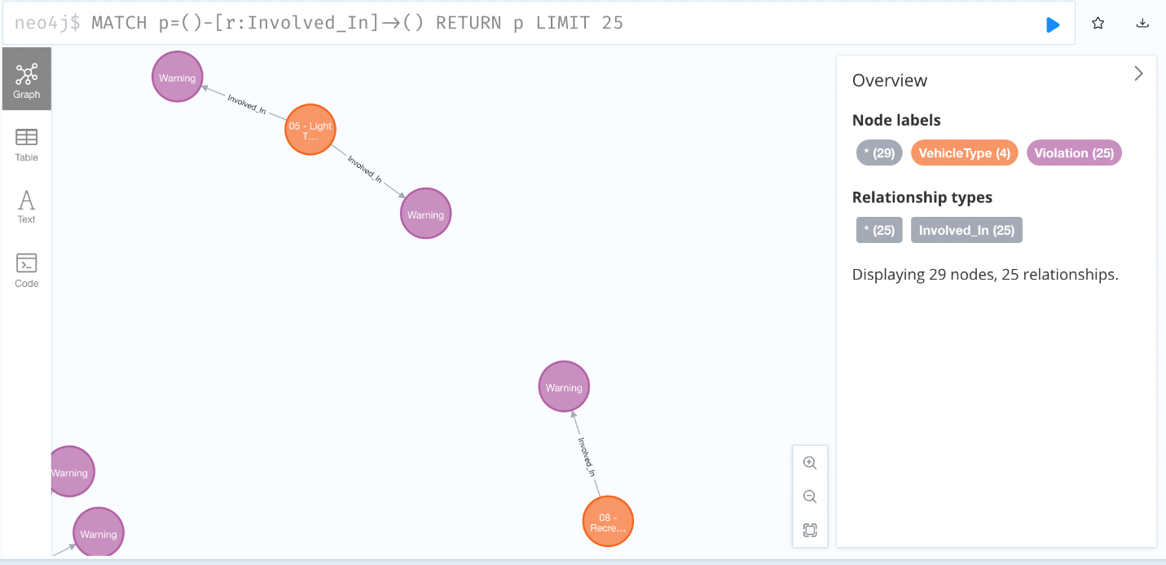

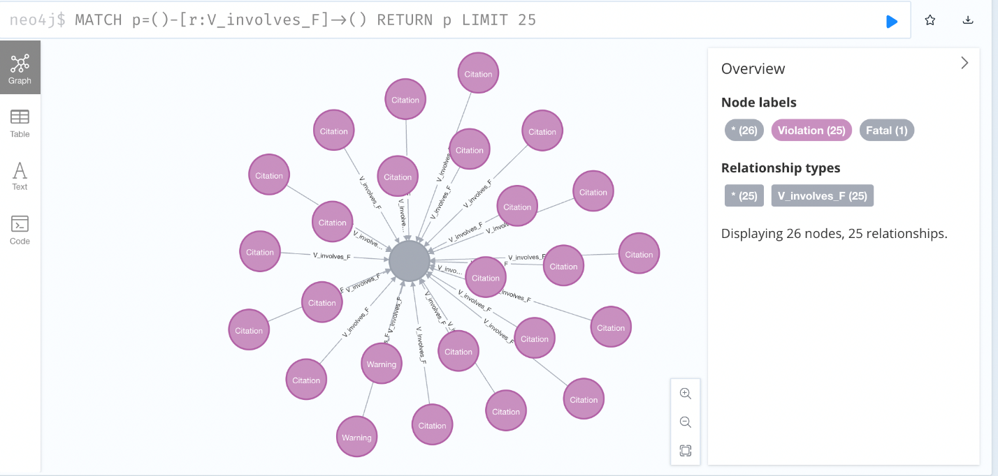

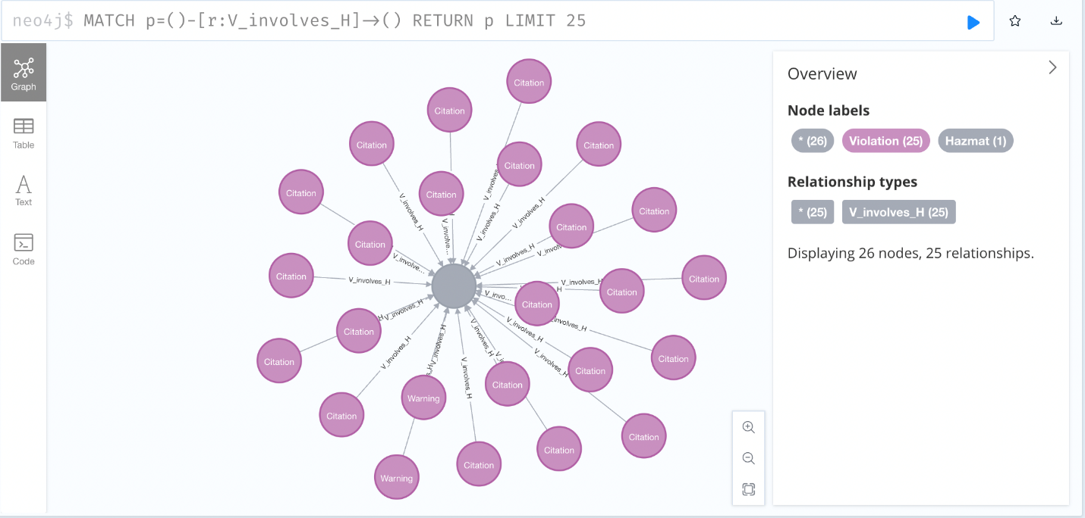

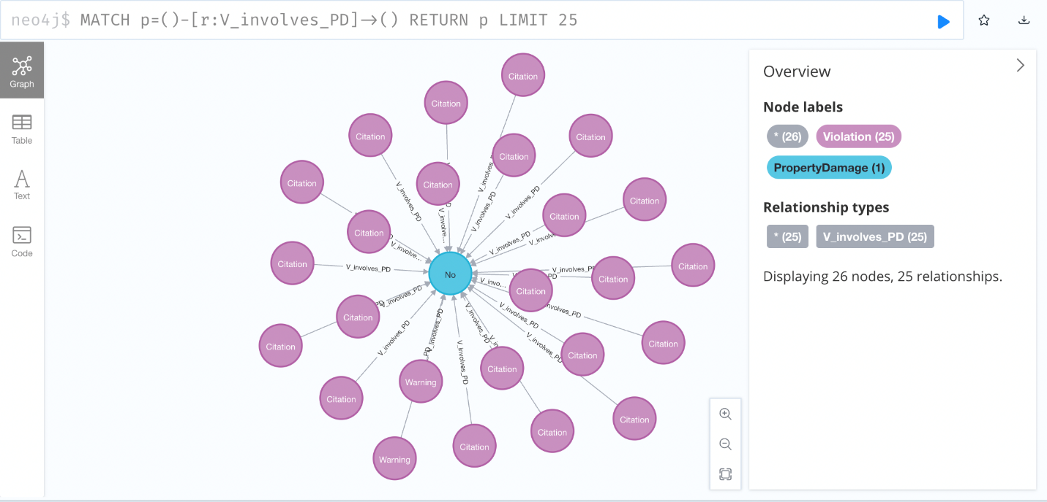

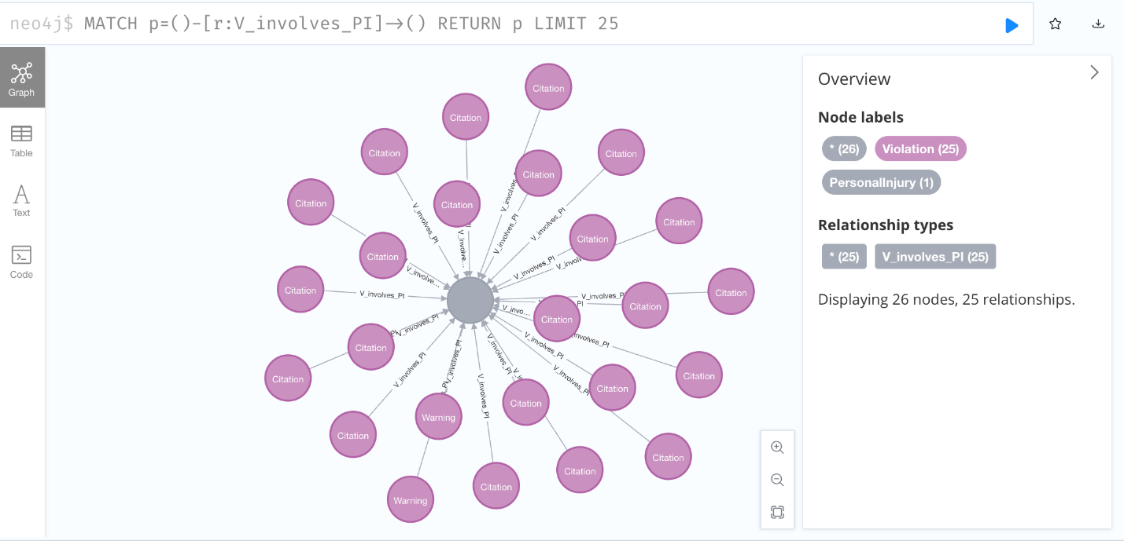

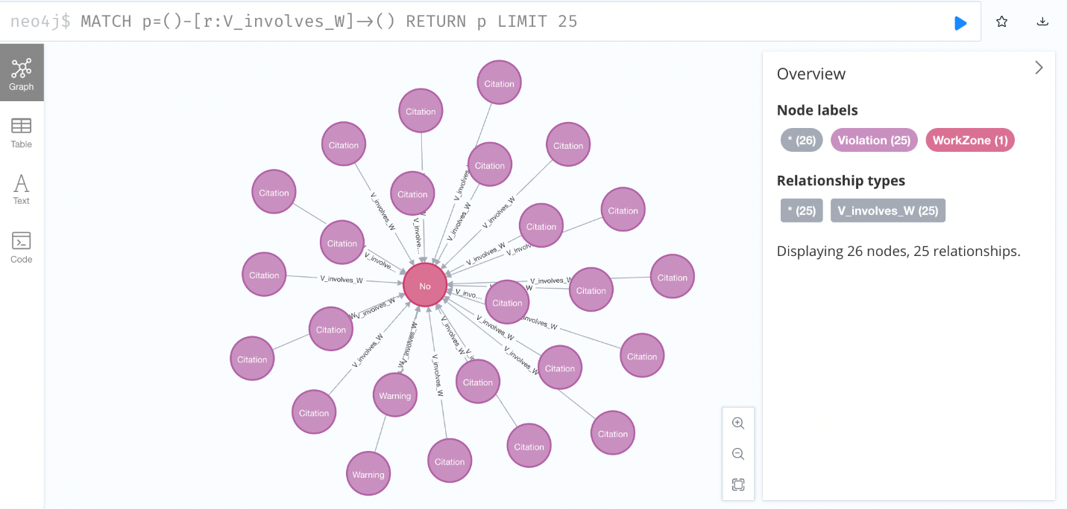

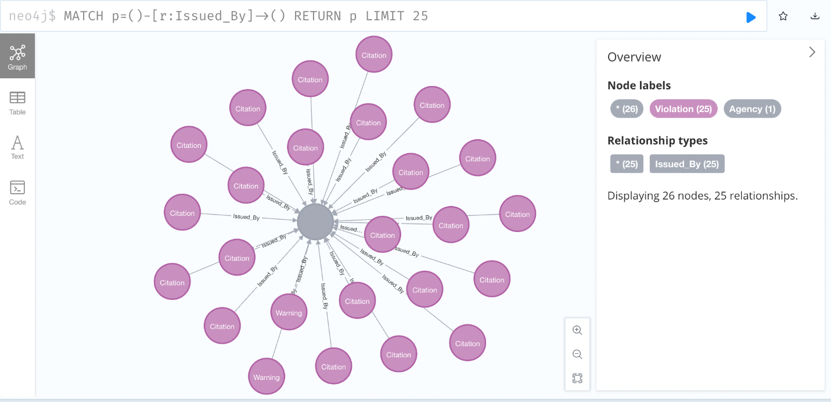

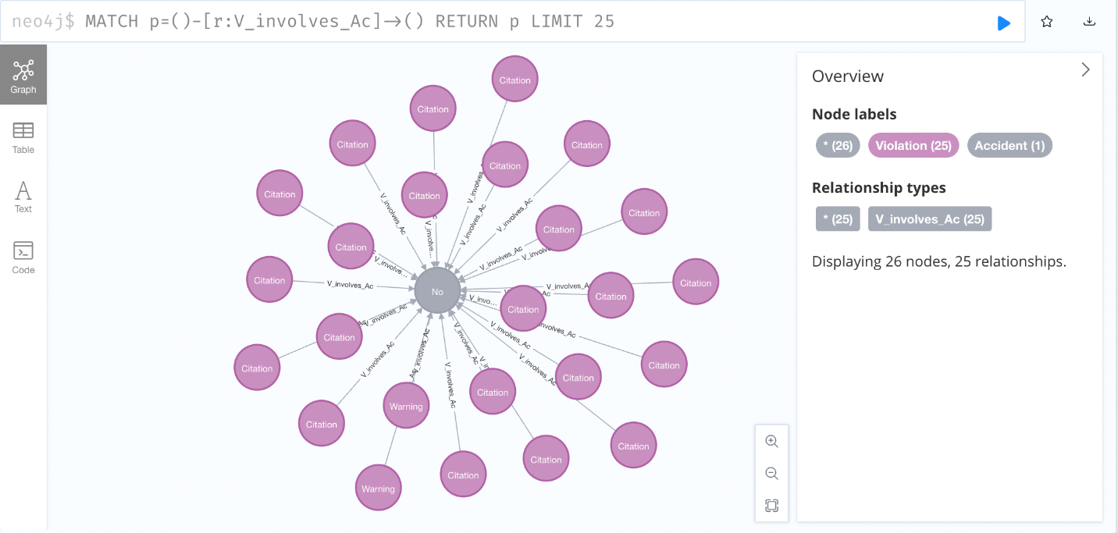

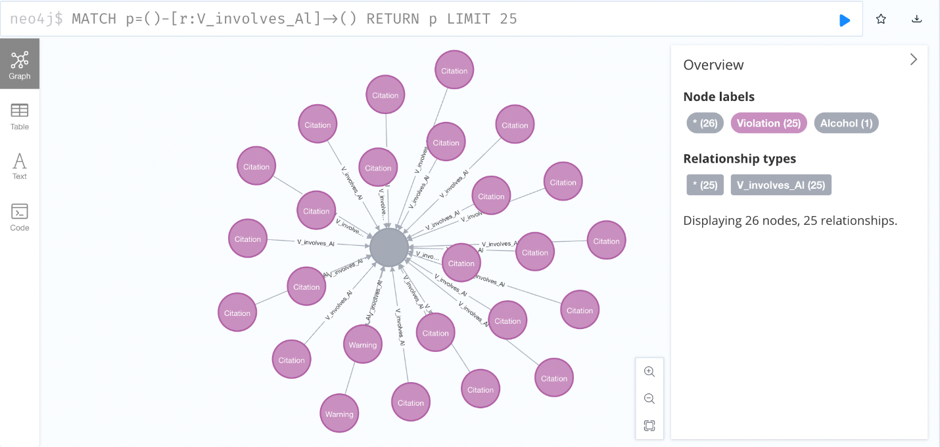

## Data Validation and Data Visualization

Originally our dataset had 44 columns but after deciding what is useful for our analysis we dropped some columns and after doing that we finally decided to work with 29 columns.

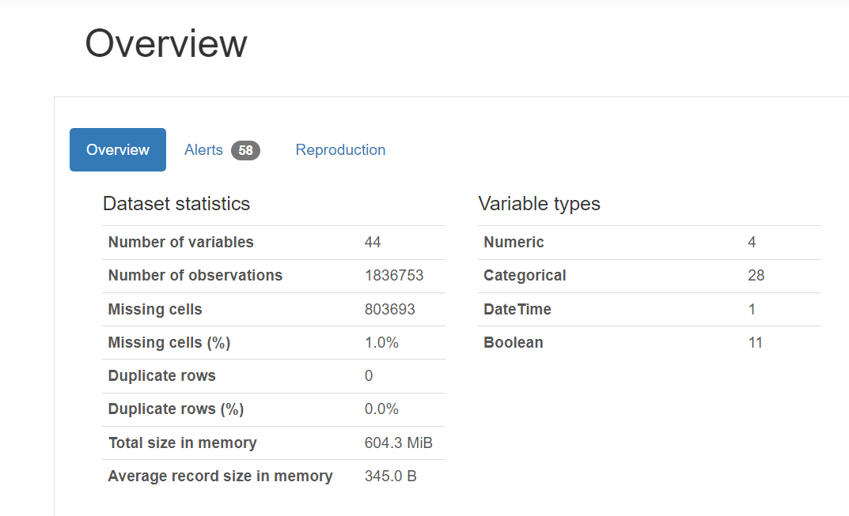

Following is the Snippet of Jupyter notebook showing the Final dataset that we loaded in our database for doing Analysis.

Snippet validates that we used all the records i.e.: 1836753

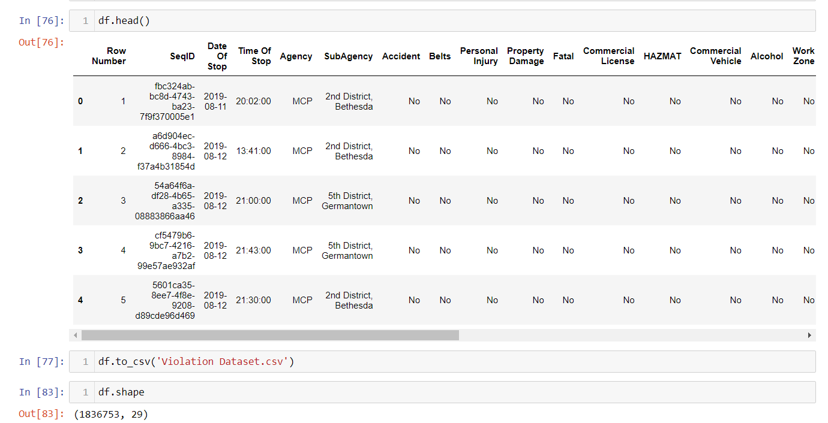

**Tableau-**

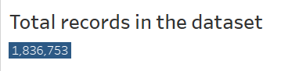

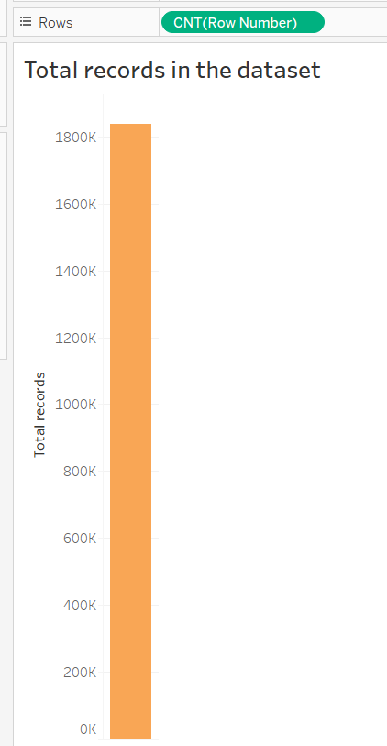

After connecting Tableau with Neo4j database, it was able to identify different relationships between nodes and by drag an drop feature we were able to generate visualizations for getting insights from data.

Following are the snippets showing those relationships between the nodes

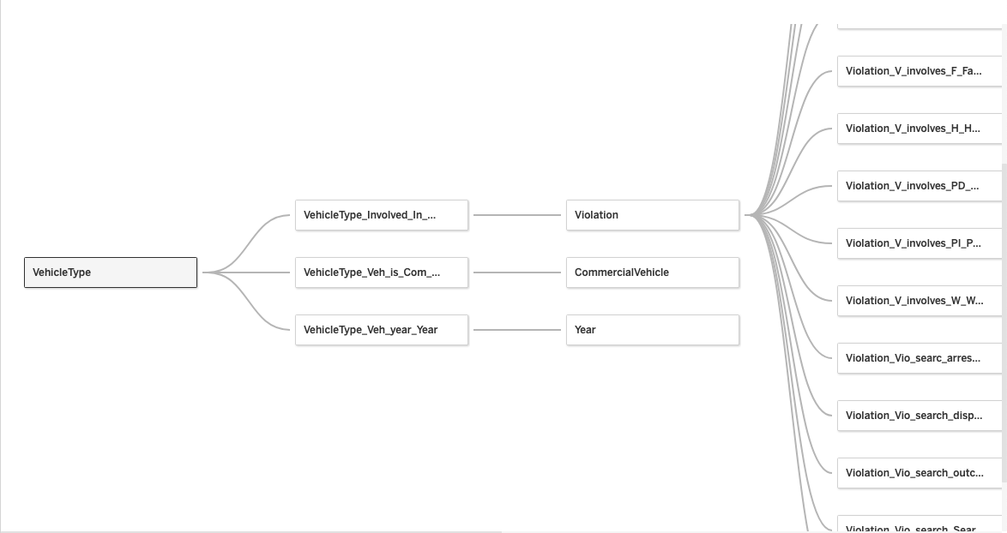

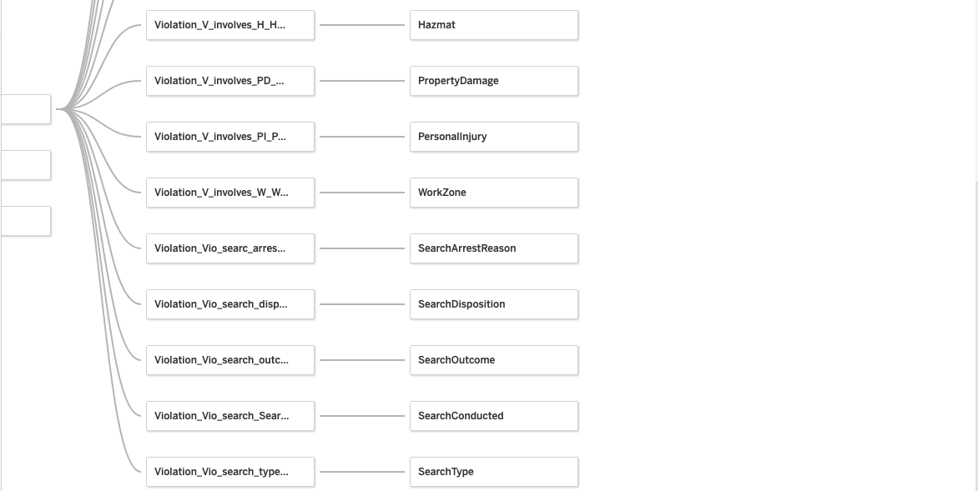

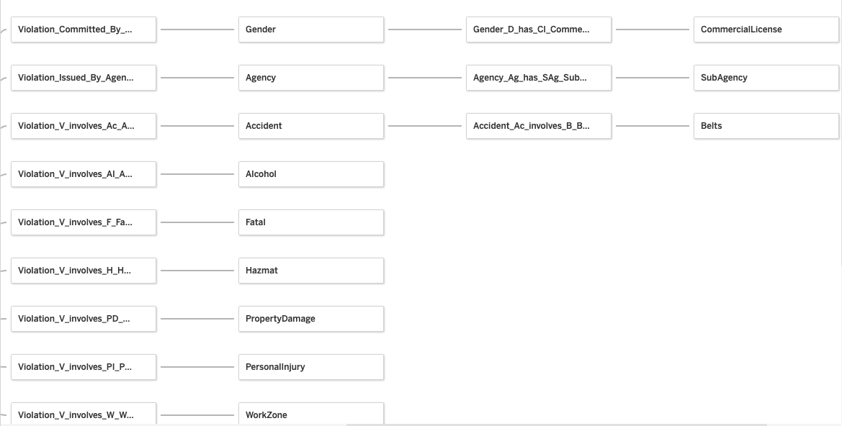

### Visualization

1. **Visualization showing count of Violations by Hour of the day-**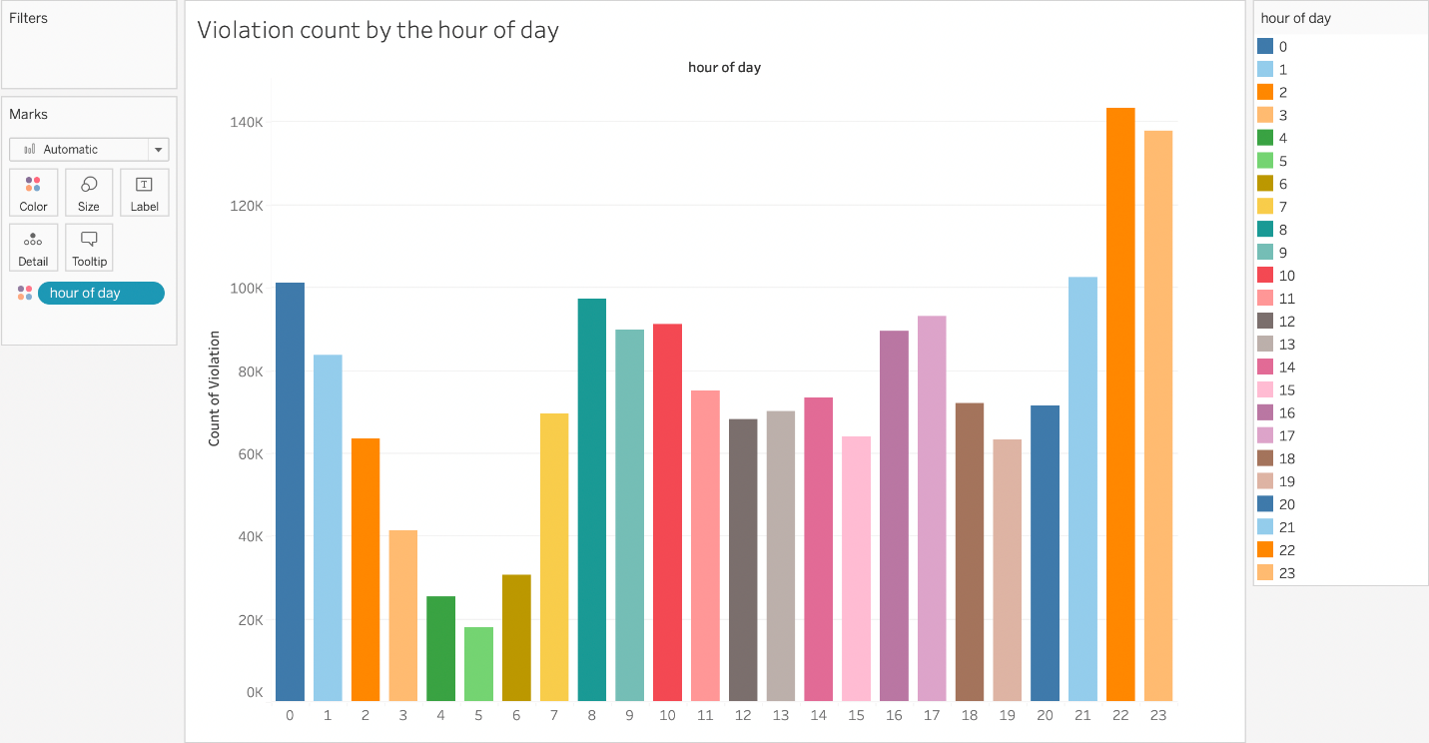

**2.Visualization showing count of Violations by Violation Type-**

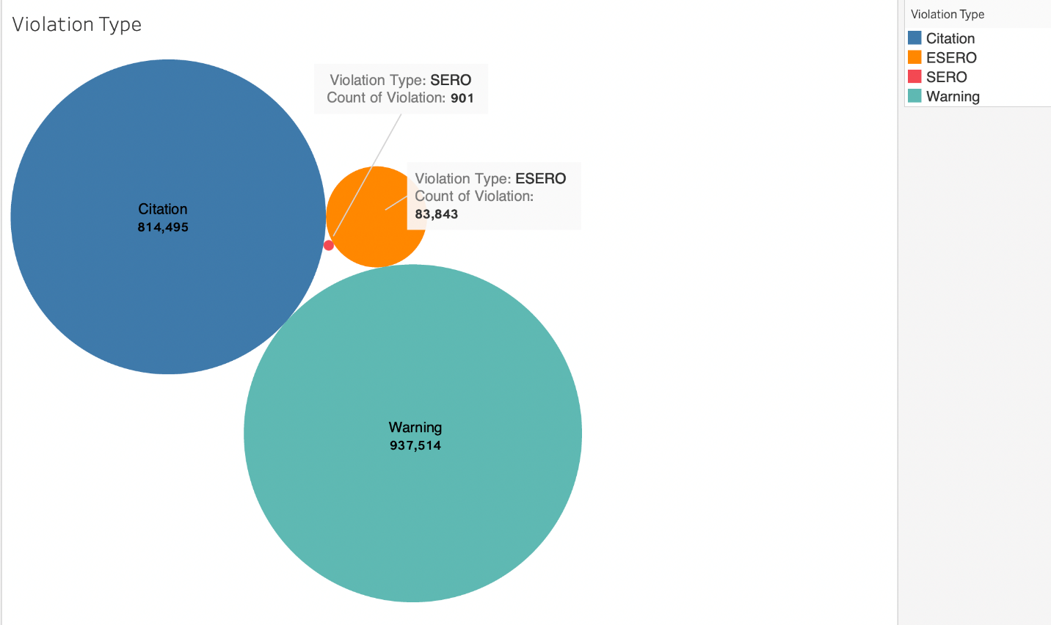

**3.Visualization showing the Count of accidents by Vehicle Types:**  
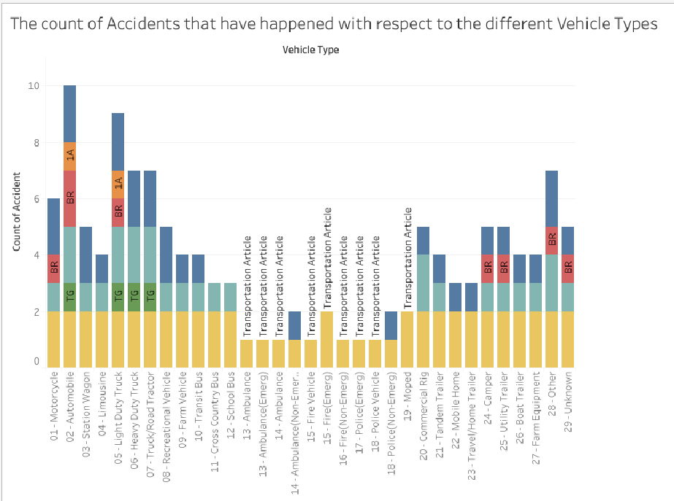

**4.** **Visualization showing Top8 commercial vehicles involved in Violation**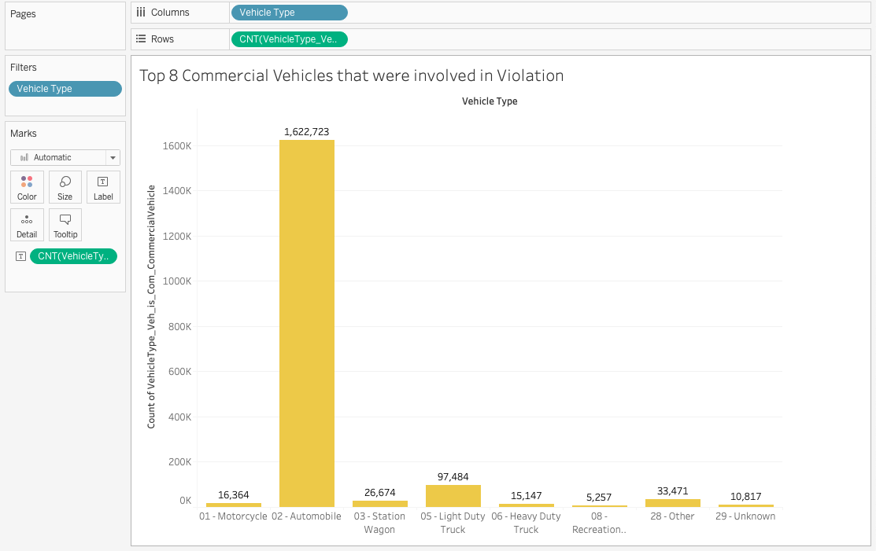

5. **Visualization showing Total count of Violations by Gender**  
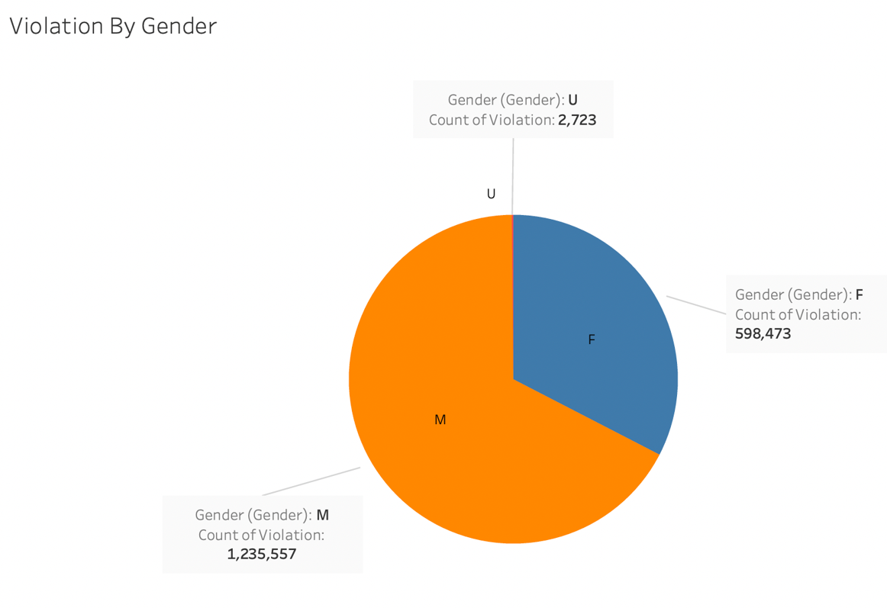

**6. Visualization showing Total count of Violations by Days of the week**

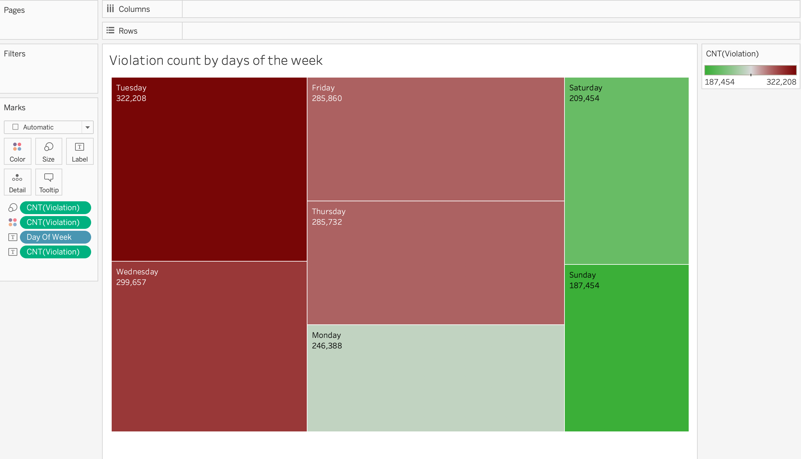

7.Total Violations by different attributes

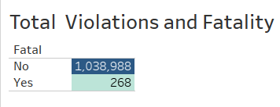

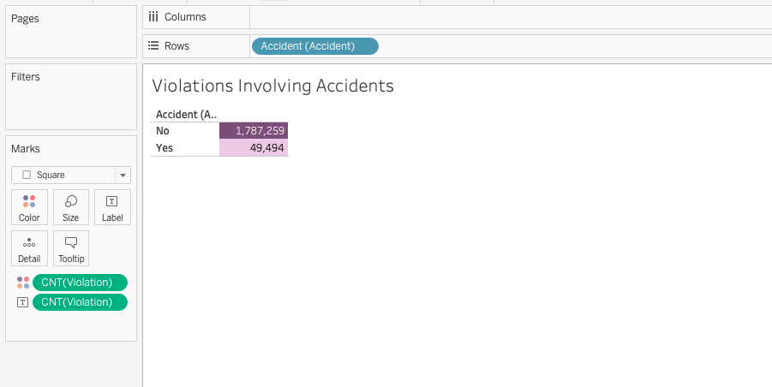

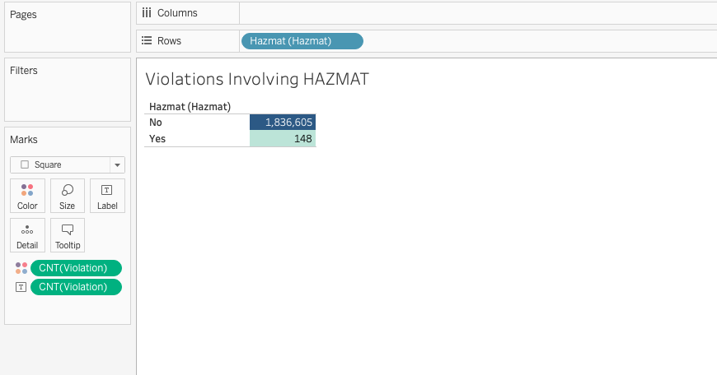

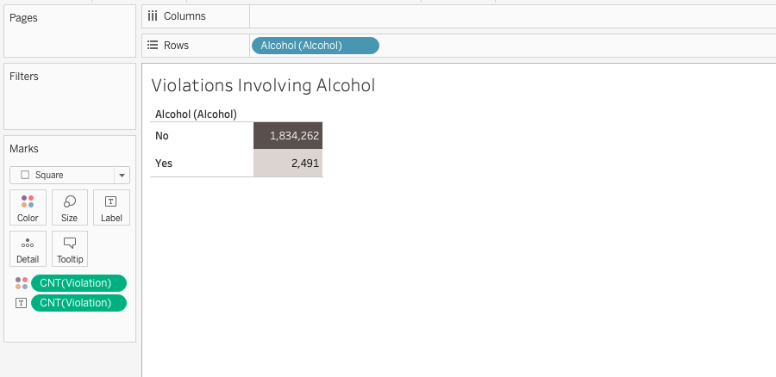

**Dashboards**

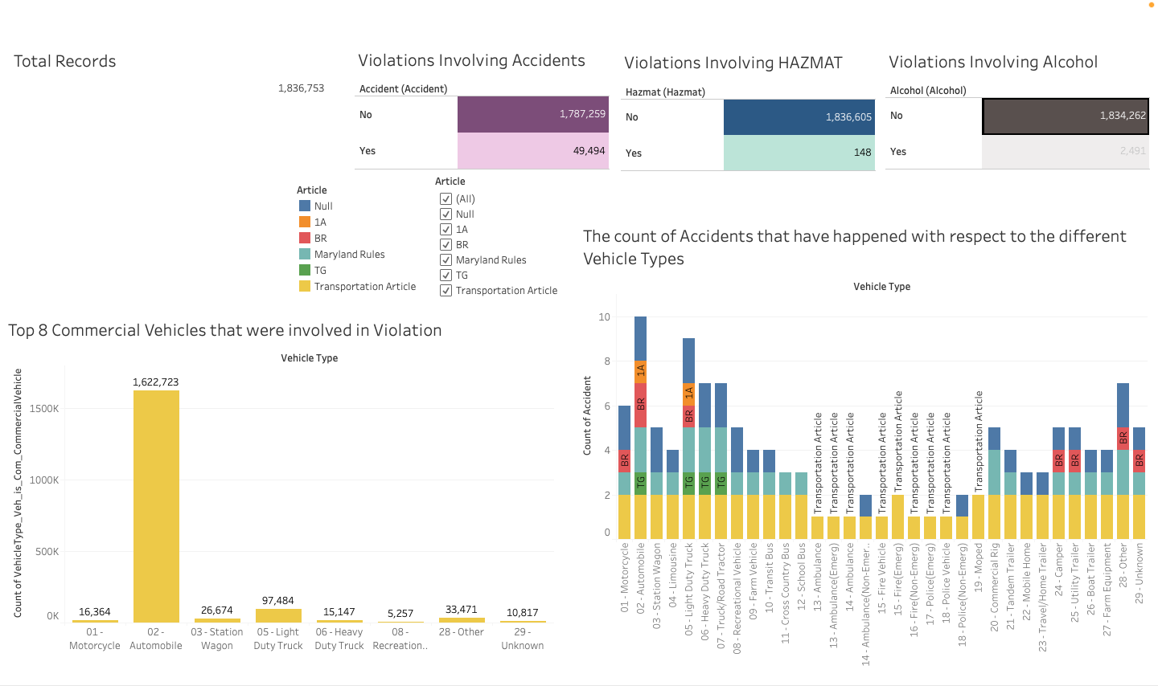

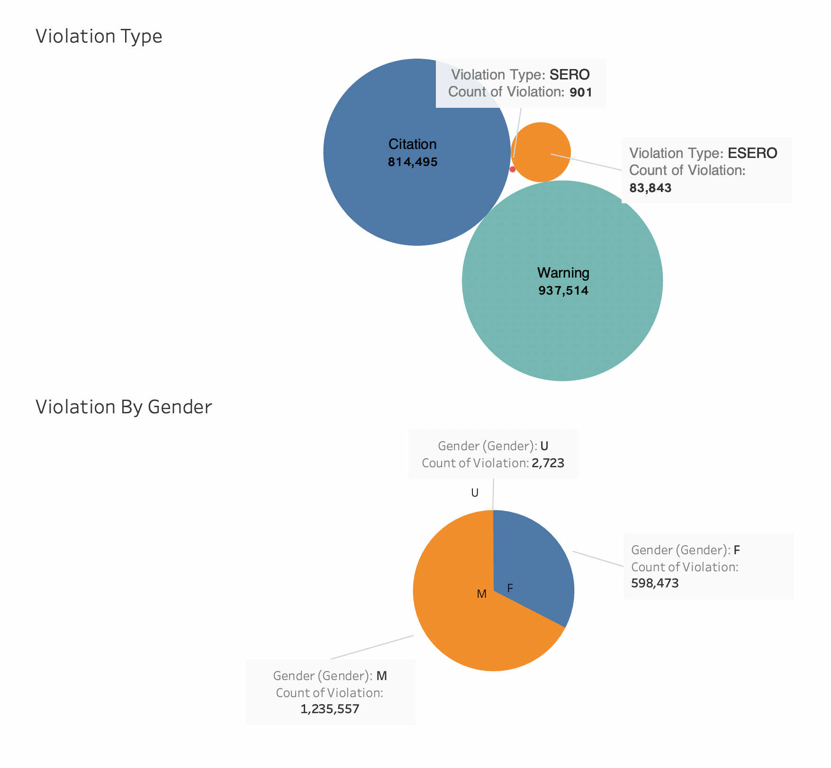

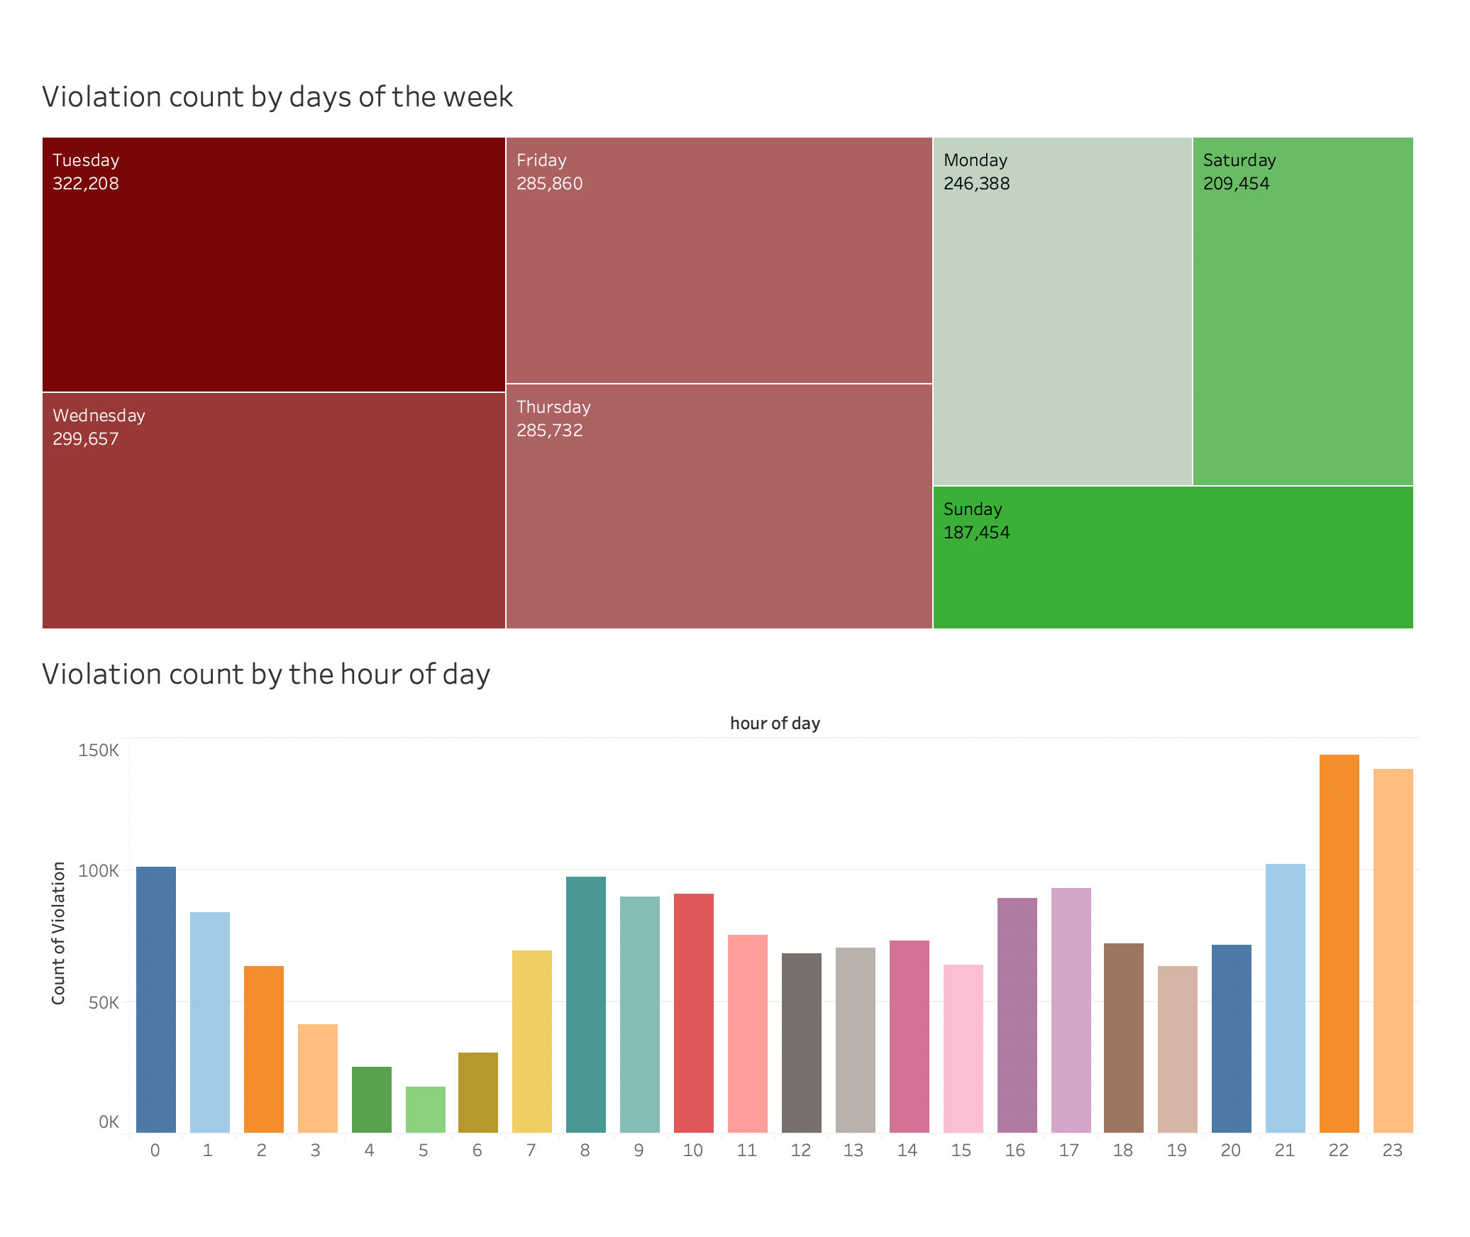

### OTHER DELIVERABLES

We have added all project-related files, including Dataset, Jupyter Notebook,Vision Diagram, Cypher code, Neo4j schema snippets showing nodes and relationships, Snippets from Velero and Tableau Worksheet, in the submission file.

## System Integration and User Acceptance Testing

Following snippet shows details about the original dataset. It had 43 columns and 1836753 records

Following Snippet shows that after Preprocessing the data ,we got rid of some unnecessary columns and finally we had just 29 columns but we had all the records (1836753)



## Challenges Encountered

* Unable to access APOC(which was needed for connecting Neo4j with Tableau) in Neo4j even after several installations and manually adding APOC files)

--This issue was not resolved

* Quarantine mode error in Neo4j while loading the data

-This issue was not resolved

* Issue in Loading data in Neo4j

- Increased heap size to resolve this issue

- Issue was resolved

* Slow data loading in Tableau

- Issue was not resolved

## End User Instructions

Following are the end user instructions for executing this project

**1.Creating and loading database in Neo4j database**

By following given steps, database can be created and loaded in Neo4j Database

First step involves creating a new Project in Neo4j

1. Next, we need to create database (we named it project) for the project

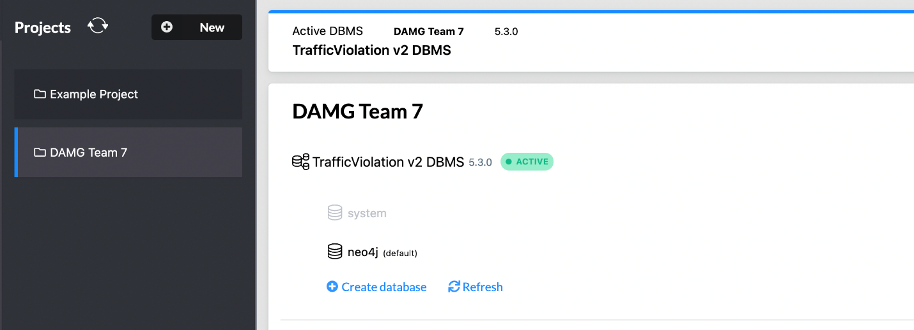

1. When the DBMS is ready, we can initiate it by selecting the start option, and then launch the server by clicking on the open button.
2. Once the terminal is launched, we can commence developing the schema and uploading data to our Neo4j database through the query terminal.



1. To load the nodes, we must establish all the constraints, which can be created by using the Cypher code supplied in the document.
2. As soon as we generate the constraints for the database, we can start loading the nodes that are distinct within the dataset.
3. Afterwards, we can use the MATCH function to load the remaining nodes and their relationship from the CSV file.
4. After all the nodes are created using the Cypher script we can query the database to analyze it.

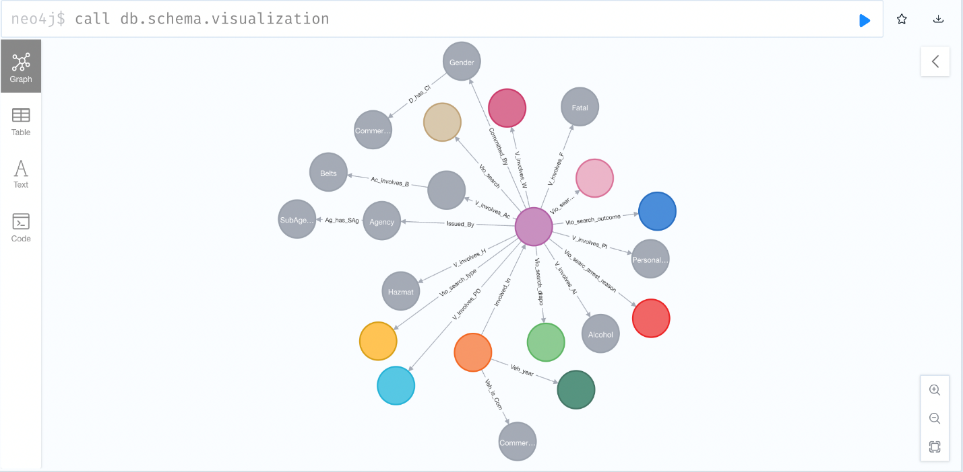

**2. Creating Data Visualizations in Tableau by connecting with Neo4j database**

By following given steps we can connect Tableau with Neo4j and create dashboards for generating useful insights from the data

1. Place the JDBC Driver in correct location
2. Launch Tableau and select "Other Databases"
3. Type in the following details: jdbc:neo4j://localhost:7687/neo4j?&UID=neo4j&PWD=password,

along with the correct password used for the Neo4j database

1. Access the attached Tableau workbook, refresh the data, and explore all the available dashboards.

3.**Running Jupyter Notebook for getting the cleaned Data**

Follow given steps for opening the Jupyter notebook included in the folder

1. Collect the data from the official website using the following link:

<https://data.montgomerycountymd.gov/Public-Safety/Traffic-Violations/4mse-ku6q>

1. Run the jupyter notebook provided in the Project Folder
2. After running successfully, the dataset will be downloaded as ‘ Violation Dataset.csv’, use path of this dataset in the Cypher script to load the data in the database.